Liam Courtney

Dundee and Angus college  1625542

Simply Rugby

analysis and design

Table of Contents

Analysis of the Project Brief 3

Interpretation of the Project Brief 3

Aims of Projects 3

Requirements 3

Functional Requirements 3

Non-functional Requirements 5

Research 5

Chairman Interview 5

Current Paper-based Forms 9

Similar Systems 13

Rugby Union 16

SCRUMS 16

Insurance 17

User Groups 17

Users 17

Stakeholders 18

User Scenarios 19

Secretary 19

Coach 20

Task Analysis 21

Secretary 21

Coach 21

Assumptions 22

Constraints 22

Security Requirements 22

SQL Injection 22

GDPR / Data Protection Act 23

Password Policy and Encryption 23

Performance Requirements 23

Server-side 23

Client-side 23

Resources and Materials 25

Asset Log 25

Hardware 26

Software 26

Project Plan 27

Production of Plan 27

Tasks 30

Planning 30

Implementation 31

Testing 32

Evaluation 33

Schedule 34

Milestones and Deliverables 35

Planning 35

Implementation 35

Testing 36

Evaluation 36

Main Tasks 37

Resources 37

Hardware 37

Software 37

Analysis and Design of Solution Plan 38

Business Model 38

Use Case Diagram 38

Activity Diagram 39

CRC Cards 40

Class Diagram 40

Sequence Diagrams 41

ERD 46

View Model 47

Wireframes 47

Data Binding 57

References 60

# Analysis of the Project Brief

## Interpretation of the Project Brief

‘Simple Rugby’ have teams playing Rugby at different age levels, backed by the ‘Scottish Rugby Union’ (SRU). These teams play at junior and senior levels; each team is managed by a group of coaches, usually parents or guardians of players in each team. All playing or non-playing members must be registered with SRU to ensure SRU’s insurance covers them. Junior members must also provide a consent form signed by a parent or guardian every season and personal information for two guardians. The junior and senior levels have a chairman and secretary responsible for organising fixtures for each team.

A coach or a parent/guardian from every team creates a paper trail of all the players’ details, including doctor and parent/guardian information. The coach or parent/guardian will also create a paper record of each player's skills ranked from one to five to help organise appropriate training sessions; the categories of skills tracked are passing, tackling, and kicking, along with subskills in each category such as front tackling or spin passing. These skills are used to put players forward for different pathway development and to decide on the most optimal position for each player, as the best position might not be evident until the player has played several positions.

Details of training sessions are also recorded in paper forms, including the date, time, and location of the session and the coach organising the session. The players that attended the session are also recorded, as well as the skills and activities undertaken and any accidents or injuries.

Details of matches played are also recorded in paper forms by the coach or parent/guardian of each team; this includes pre-match information such as the opponent, date, location, and kick-off time. In-game data is also recorded, including the result (win, loss, draw), match score, and first/second-half performance.

Ultimately, the chairman and secretary are responsible for the outer workings of the team, such as appointing coaches and managing fixtures, and the inner workings of each team, such as player, match, and training information, are controlled by the coaches of each team.

## Aims of Projects

This application aims to create a more efficient system for storing playing and non-playing members’ details. As well as more information on player’s skill development and performance in training sessions and matches. Due to the current paper-based system, this isn’t the most effective way to achieve this goal for an organisation of Simply Rugby’s size. A new electronic system would include a database for storing/accessing information and a graphical user interface for simpler inputting and accessing information.

## Requirements

### Functional Requirements

#### **High Priority (Required)**

**Secretary:** Add teams at different age levels, such as junior and senior.

**Secretary:** Input and store non-playing members’ (coaches) personal details, including name, SRU number, address, postcode, phone number, and email address.

**Coach:** Input and view players’ details, including name, SRU number, possible positions, address, postcode, date of birth, phone number, email address, next of kin’s name and contact information, and finally, doctor’s name and contact information. Junior players are required to provide extra guardian information as well as a signed consent form each year.

**Coach:** Track and view individual player’s skills in different categories and subcategories, including:

* Passing:
  + Standard
  + Spin
  + Pop
* Tackling:
  + Front
  + Rear
  + Side
  + Scrabble
* Kicking:
  + Drop
  + Punt
  + Grubber
  + Goal

**Coach:** Keep viewable records of individual training sessions with information such as date, time, location, skills practised, activities undertaken, players present, accidents/injuries, and the coach organising the session.

**Coach:** Keep viewable records of matches played with information such as opposition, date, kick-off time, location, result, score, and first/second half performance.

#### **Medium Priority (Optional)**

**All Users:** Create an account with permissions based on the user’s role within the organisation.

**All Users:** Login to the user’s account with access based on their role within the organisation.

* **Secretary:** Admin account with access to the whole system.
* **Coach:** Account with access to their team’s players, training sessions, and matches.

**Secretary:** Verify non-playing members’ SRU numbers manually before being allowed access to their accounts.

**Coach:** Calculating an average of each player’s skills in each category and the total average overall categories.

**Coach:** Track players’ previous skill development, showing the progression made by the player.

#### **Low Priority (Time-dependant)**

**All Users:** Keep a viewable record of previous seasons and all the information accompanying them.

**Coach:** Track players’ previous progression through different age levels.

**Coach:** Determine the ideal position based on the player’s skills.

**Secretary:** Track coaches’ skill levels of training players in each skill category and subcategory.

**Coach:** Submit an electronic consent form with online signatures.

### Non-functional Requirements

#### Design

* A blue and white colour scheme based on Scottish Rugby (Scottish Rugby, 2024).
* Design a logo based on the Scottish Rugby logo (Scottish Rugby, 2024).
* Minimalist design for more straightforward interactions to aid users with little technical knowledge.

#### Accessibility

* Larger font size for visually impaired users such as the secretary.
* Simple font choices for visually impaired users, such as the secretary.

#### Time

* The system planning should be completed by 23rd February 2024 to ensure enough time for development and testing of the system.
* The development should be completed by 19th April 2024 to allow enough time for appropriate testing and necessary changes.
* The final system must be completed by the chairman's 10th May 2024 deadline for the upcoming season.

## Research

### Chairman Interview

An initial interview was held with the chairman to gather more information about the current system and the requirements for the new system. The following questions were translated into less technical terms and asked to the chairman:

|  |  |
| --- | --- |
| Deadline? (full version, any prototypes?) | The chairman declared the 10th of May 2024 as the final deadline for the upcoming rugby season. |
| What previous technology has been used? (bespoke or general) | There is a paper-based system of coaches submitting forms to the secretary. |
| Who needs to read/write the data? (technical knowledge, accessibility) | The secretary, an elderly woman with sight issues, is currently the overall administrator of the current system, storing and processing forms submitted by coaches. |
| How will they be using it? (use cases, key goals) | * Add teams to the system. * Add non-playing members to the teams. * Add players to the teams. * Track player skill development. * Track training sessions. * Track match data. |
| What systems will the application be used on? (Desktop, mobile, operating system) | The secretary currently uses an old desktop with an outdated version of Windows (possibly XP). |
| Is the data local or online? | This was left up to the developer’s expert opinion. |
| Does the data need to be exported to a document? | This was left up to the developer’s expert opinion. The coaches only need to see the outputted data. |
| Which specific player details are to be stored? |  |
| Does previous player data transfer to higher levels? | This is not a requirement; the player is technically treated as a new player each season. If time and budget are available, this could be implemented. |
| Are the coach's details to be stored? |  |
| Do players move up age grades together or individually? | The players move up the age groups together as a team. |
| Are details to be accessed without viewing skills or match/training data? | This was left up to the developer’s expert opinion. |
| Which skills are tracked? |  |
| How are skills tracked? (rating out of 5 stars, 100 points, whole numbers, etc.) | See above, which is currently rated between 1 and 5. A more visual star system was suggested, and the chairman agreed. |
| Does skill improvement need to be tracked or just changed? (showing progression) | They are updated every time; the progress can be tracked if time and budget are available. |
| What details are stored for each match? |  |
| What details are stored for each training session? |  |
| How do training sessions and matches affect skills? | The coaches update players’ skill development as they deem necessary. |
| Who updates player skills? | The coaches of each team manage players’ skill development. |
| Is there a specific design preference? | This was left up to the developer’s expert opinion. |
| Is there a specific colour scheme? | Blue and white, based on the Scottish Rugby colour scheme (Scottish Rugby, 2024). |
| Any custom logos, fonts, etc? | The current font is just the default Microsoft Word font; the developer can change this. There is no logo currently, but one can be designed by the developer based on the Scottish Rugby logo (Scottish Rugby, 2024). |

A second round of questions was asked to the chairman to clarify some points that still weren’t clearly understood. The following questions were asked through online messages and cleared up everything:

|  |  |
| --- | --- |
| How many teams in total? (Estimate) | “There are seven teams in mini, six in midi, and one as senior.” |
| What age group does junior become senior? | “Think of Juniors as school ages. Seven teams for primary classes, one for each year, six for secondary classes, and one for each year. After school, if they wish to join, they would join as seniors.” |
| How many players per team? (A range is acceptable) | “Fifteen players are playing in a senior game at any one time, but there could be many more in the team, and they will swap positions. There may be as little as 10 for school-age teams, and the maximum is 30.” |
| Should subs be tracked in this system? | “Subs don't need to be tracked in this system, though we may expand into this later.” |
| Are subs paid weekly or monthly? | “Subs are paid annually.” |
| Do different teams pay different amounts in subs? | “Different levels of teams pay different amounts, but this is held in our finance system.” |
| Does the opponent change each half of the match, or does it stay the same? (Regarding the match form, opponent input appears in multiple sections) | “Lineups are usually the same unless substitutes are playing. There can be eight substitutions made throughout the game.” |
| **Follow-Up Question: I asked if the opposition changes in each half regarding the current paper form; does the opposition have** **an option in both halves?**  image | **Developer:** “I believe I was looking at it wrong. They appear to be headings looking at it again, but it wasn’t clear at first glance.”  **Chairman:** “Ah, I wondered if you thought they were playing different teams or just different players. In reality, the coaches won't know much about the opposition but like to take notes on their techniques or strategies for future reference and training.” |

### Current Paper-based Forms

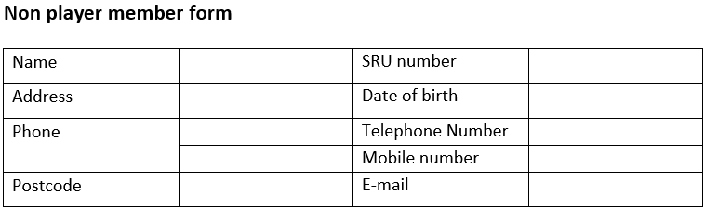

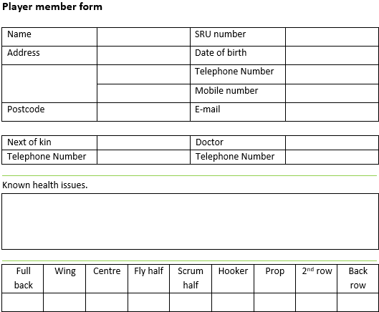

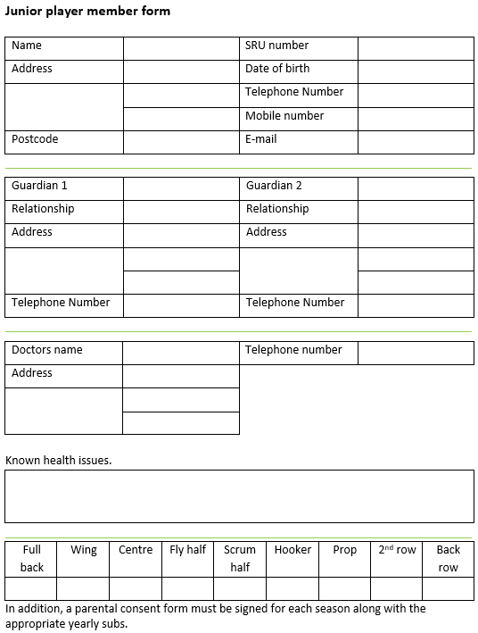

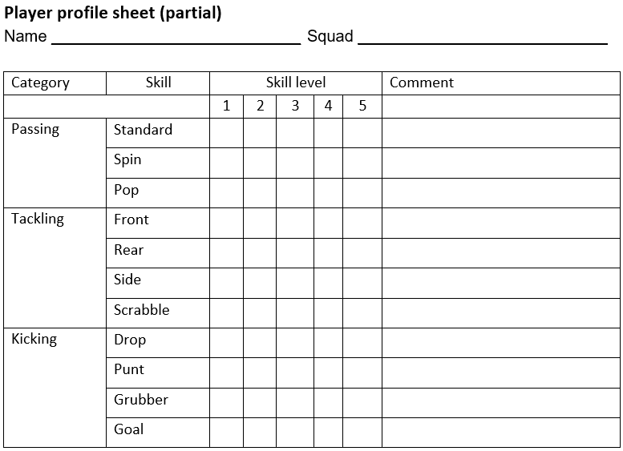

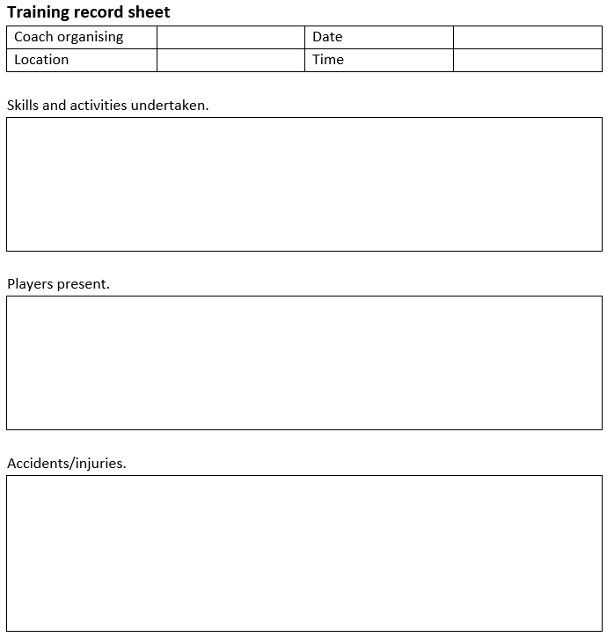

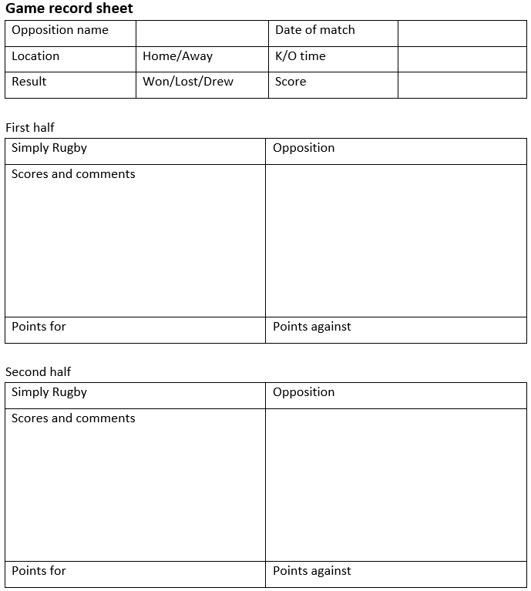

### Similar Systems

#### Football Scores

A previous system built by the developer that was very similar but for the intended use of a football association was shown to the chairman. The chairman agreed that this was very similar to what he had imagined, covering many of the use cases Simply Rugby required. It was decided that Simply Rugby’s system would take the initial design/concept of this system and build on it.

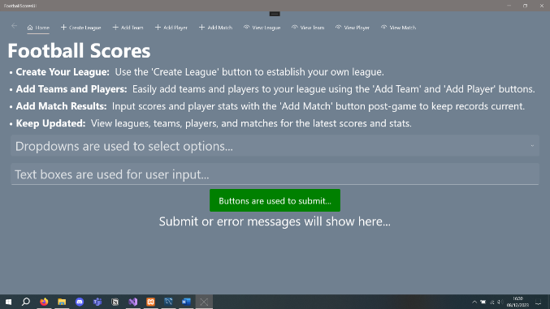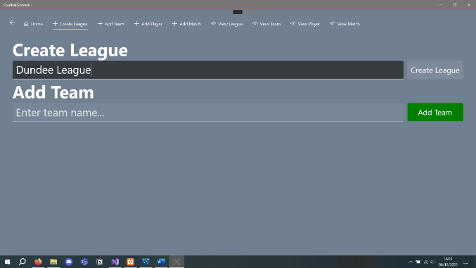

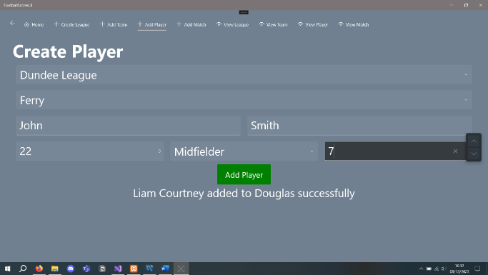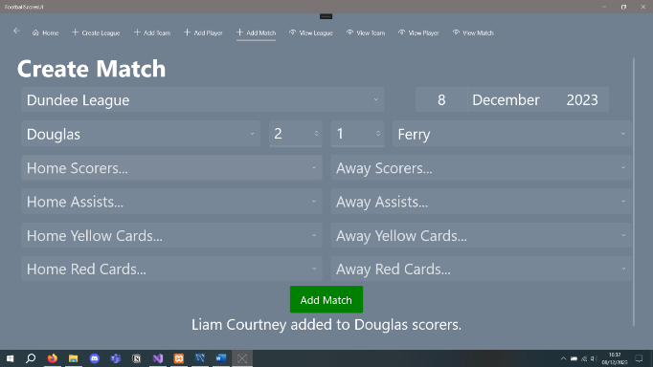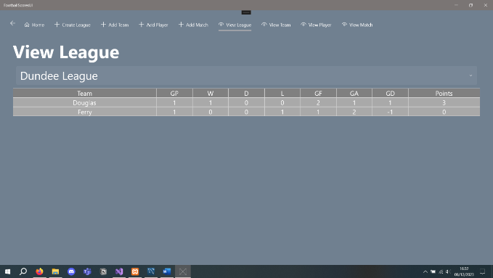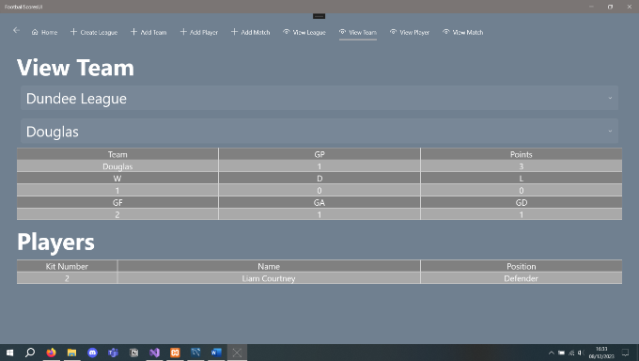

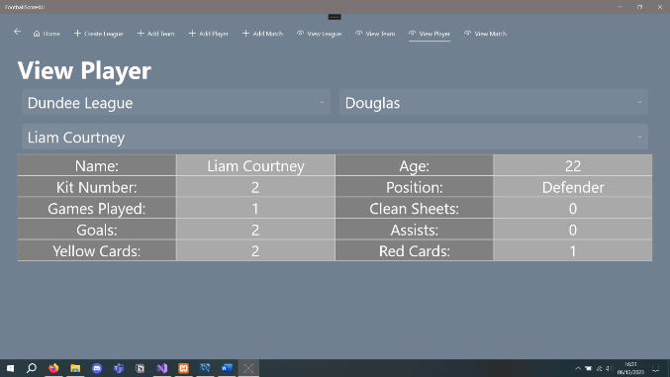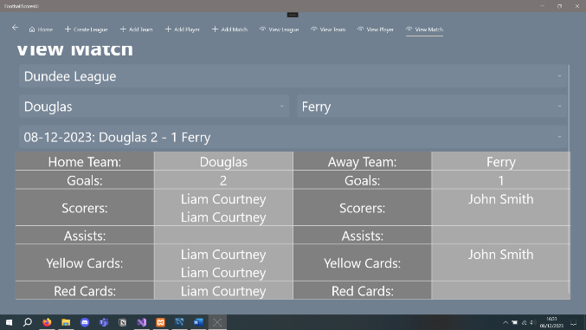

#### Football Manager Player Profile

Although this is a game based on football management, the player profile is a great design concept, and a similar system could be implemented in Simply Rugby’s system for player profiles. The chairman agreed on the star system, and the other sections can be repurposed into more appropriate metrics for their system.

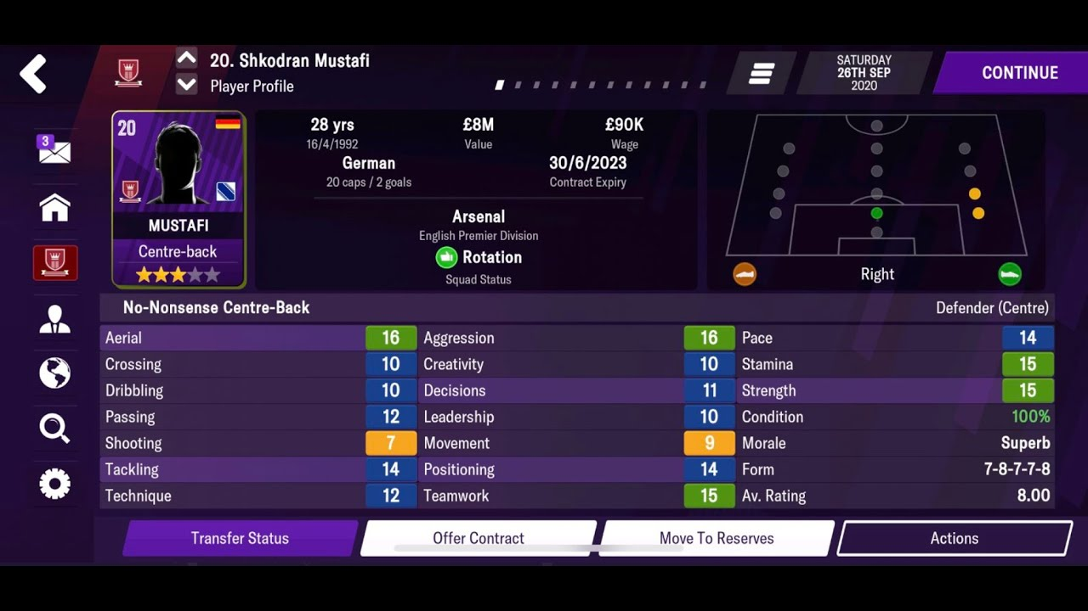

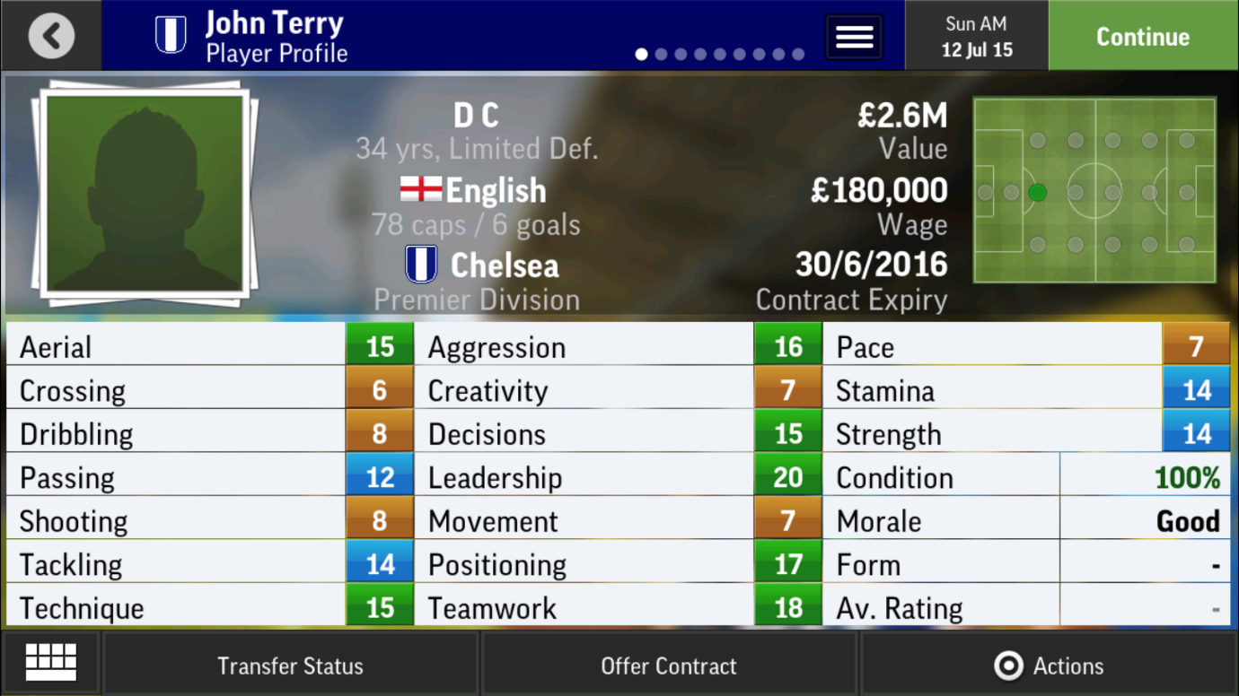

#### Pitchero

Pitchero is an online sports management tool used by many sports, including Rugby Union (Pitchero, 2024). This tool covers a wide range of management tools, but the downside to this is its complicated nature. Organisations such as Simply Rugby only need specific features such as player and team management; the rest of the features clutter the system for users. Pitchero will exemplify the need to keep the system simple but effective.

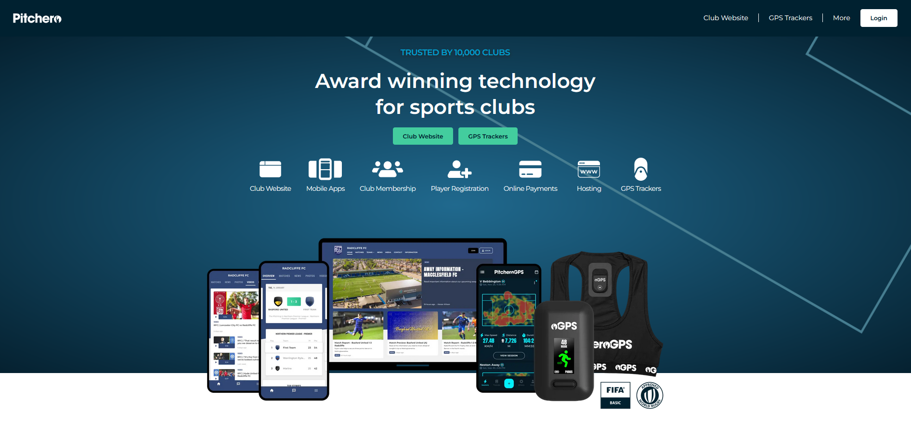

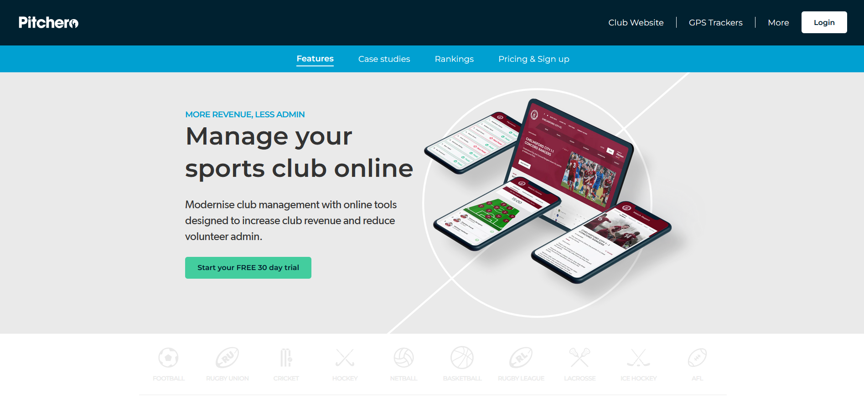

### Rugby Union

Rugby union is a sport played in two teams of fifteen players; the lower age groups play with a range of six to thirteen, changing to fifteen as they become old enough (Scottish Rugby, 2022). There are different ways to score points. These are try (5 points), penalty (3 points), conversion (2 points), and drop goal (3 points) (World Rugby, 2024). There are a wide range of positions, each with its duties and skillset; these positions work together defensively and offensively to score as many points as possible while conceding as little as possible. The winner at the end of the match is the side with the most points. Rugby Union is played by grassroots and international professionals.

### SCRUMS

“The Scottish Rugby Management System, known as SCRUMS, was launched in 2018 to record all player, club official, club volunteer and staff registrations” (Scottish Rugby, 2024).

SCRUMS is an online portal for teams and organisations’ SCRUMS liaisons to add players and coaches to their teams. This will be used alongside Simply Rugby’s new electronic system to verify players and coaches before adding them.

### Insurance

Scottish Rugby provides personal accident and public liability insurance for affiliated clubs, covering the whole club. The insurance covers training sessions and matches, and “each club must send Scottish Rugby an Insurance Proposal Form each season” (Scottish Rugby, 2024). Guest players are also covered under the insurance if they play for an affiliated club.

## User Groups

After an initial meeting with the chairman of Simply Rugby, the chairman provided a document with some information on the future users of the system as well as the chairman himself. Some additional questions were asked to clarify gaps in the information. Below are the prospective users' and stakeholders’ profiles based on the initial meeting.

### Users

#### Secretary

|  |  |
| --- | --- |
| **Relationship** | * Administrator for the overall system. |
| **Key Goals** | * Manage the administration for each team. * Manage the administration for the non-playing members. |
| **Characteristics** | * Elderly woman in her eighties. * Sight issues. * Very basic understanding of technology; she can use Microsoft Windows and some essential tools such as Microsoft Office. |
| **Tasks** | * Add teams in each age group to the system. * Add non-playing members to each team and input their details into the system. * Verify non-playing members’ SRU numbers before allowing access to the system. |
| **Constraints** | * Basic fonts, easily read. * Larger font sizes. * Simple design (forms, navigation etc.) |
| **Technical Environment** | * Older desktop (no knowledge of technical specifications): the organisation has stated there is a budget for an upgrade. * Outdated version of Microsoft Windows (possibly Windows XP, unable to verify due to technical experience). |
| **Physical Environment** | * Indoor environment. * Office setting with a desk and chair. |

#### Coach

Due to a large user group of coaches, many of the following information can be a wide range of different things, but the key goals and the tasks stay the same.

|  |  |
| --- | --- |
| **Relationship** | * Administrator for their team. |
| **Key Goals** | * Add players to their team. * Track players’ skill development. * Track training session information. * Track information on matches. |
| **Characteristics** | * Often parents of the players. * Varied knowledge of technology. * Various accessibility needs (a large group of users). * Great knowledge of rugby. |
| **Tasks** | * Input players’ details. * Update players’ skill levels. * Input information about training sessions. * Input information based on matches played. * View the player’s details. * View players’ skill levels. * View information about training sessions. * View information based on matches played. |
| **Constraints** | * Large group of possible users. * Varied knowledge of technology. * Varied technical and physical environments. |
| **Technical Environment** | * Laptop or desktop, variety of technical specifications. * Microsoft Windows (most common operating system) |
| **Physical Environment** | * Mostly indoor environments, there is a possibility for outdoor environments with portable laptops. * Various lighting settings. |

### Stakeholders

#### Chairman (Client)

|  |  |
| --- | --- |
| **Relationship** | * Chairman of the organisation Simply Rugby. |
| **Key Goals** | * Work with the developer to introduce a new electronic system to replace the current paper-based system of managing the organisation. |
| **Characteristics** | * Basic knowledge of technology. * Effective communication skills. * Great knowledge of rugby and the inner workings of the organisation. |
| **Tasks** | * Meet with the developer to explain the organisation’s inner workings. * Set requirements for the system functionality. * Clarify any issues or questions with the developer about the organisation or new system. |
| **Constraints** | * Possible uncertainty about the system’s requirements due to technical knowledge. * May require assistance with online meetings and communication if necessary. * Face-to-face meetings are more effective. |
| **Technical Environment** | * Desktop or laptop for online meetings, emails, or messaging. * Mobile phone (iOS or Android) for urgent enquiries. * Microsoft Windows or macOS. * Zoom, Microsoft Teams or any other convenient online meeting software. |
| **Physical Environment** | * Mostly indoor environment with standard lighting, such as an office at a desk. * Face-to-face meetings sat at a table with the developer. * Possibility of outdoor or home setting for urgent enquiries. |

#### Developer

|  |  |
| --- | --- |
| **Relationship** | * Plan, build, test, and introduce the new electronic system for Simply Rugby. |
| **Key Goals** | * Learn the inner workings of the current paper-based system. * Produce a plan for implementing and testing the future electronic system. * Implement the electronic system for Simply Rugby. * Test the complete system to ensure it works as intended. * Document and explain how to use the new system. |
| **Characteristics** | * Expert knowledge of technology. * No prior knowledge of rugby or the current system. * No current accessibility requirements. |
| **Tasks** | * Research the current paper-based system and current users. * Document system requirements and the future users’ tasks/requirements. * Create a plan and schedule for developer tasks. * Produce UML diagrams for aiding development and testing. * Develop the system using the plan created. * Test the functionality and usability of the system. * Create documentation and demonstrate the usage of the system if required. |
| **Constraints** | * Research is required on rugby as a sport and the inner workings of the current system. * Greater technical knowledge than other stakeholders and future users will be needed to simplify the system. * Time requirements for implementing the system for the upcoming season, documentation and possible training will be required for the future users. |
| **Technical Environment** | * Acer Swift 3 laptop (8GB DDR4 RAM, AMD Ryzen 5 4500U with Radeon Graphics 2.38 GHz, 64-bit operating system, x64-based processor). * Wi-Fi 6E compatibility. * Microsoft Windows 10 Version 22H2. * It has a built-in keyboard and display (14” FHD IPS Display). * MX Master 3S computer mouse. * Location-based use of a second screen; this will be a variety of displays. |
| **Physical Environment** | * Office-based setting with natural and artificial lighting. * Home working in a simulated office environment with natural and artificial lighting. * Portability due to the use of a laptop. |

## User Scenarios

### Secretary

#### Adding a team to the system.

The user would turn on their device/computer and load up the application; the user would navigate to the login page using the navigation bar. Adding a team would only be available to the secretary; they would have to log in to their account to access the ability to add a team. Then, they would navigate to the Add Team page, enter the team’s name or age group, and click the submit button.

#### Adding non-playing members to a team.

The user would turn on their device/computer and load up the application; the user would navigate to the login page using the navigation bar. Adding a player would only be available to the secretary; they would have to log in to their account to access the ability to add a coach. Then, they would navigate to the Add Coach page, select the team to add the coach to, enter the coach’s data, and click the submit button.

### Coach

#### Adding a player to their team.

The user would turn on their device/computer and load up the application; the user would navigate to the login page using the navigation bar. Adding a player would only be available to the team's coach or secretary if no coaches could access the application; they would have to log in to their account to access the ability to add a player. Then, they would navigate to the Add Player page, as they would only have access to their team; they would then enter the player’s data and click the submit button.

#### Updating players’ skill development.

The user would turn on their device/computer and load up the application; the user would navigate to the login page using the navigation bar. Updating player’s skills would only be available to the team's coach or secretary if no coaches could access the application; they would have to log in to their account to access the ability to update skills. Then, they would navigate to the Player Details page, as they would only have access to their team; they would then select the player, click the skills button, then the edit button, and finally enter the player’s skills, and click the submit button.

#### Recording information on training sessions.

The user would turn on their device/computer and load up the application; the user would navigate to the login page using the navigation bar. Adding training session data would only be available to the team's coach or secretary if no coaches could access the application; they would have to log in to their account to access the ability to add match data. Then, they would navigate to the Add Training Session page, as they would only have access to their team; they would then enter the training session data and click the submit button.

#### Recording information on matches played.

The user would turn on their device/computer and load up the application; the user would navigate to the login page using the navigation bar. Adding match data would only be available to the team's coach or secretary if no coaches could access the application; they would have to log in to their account to access the ability to add match data. Then, they would navigate to the Add Match page, as they would only have access to their team; they would then enter the match data and click the submit button.

#### View player, match, and training session data.

The user would turn on their device/computer and load up the application; the user would navigate to the login page using the navigation bar. Viewing data would only be available to the team's coach or secretary if no coaches could access the application; they would have to log in to their account to access the ability to view data. Then, they would navigate to the corresponding ‘View’ page and view the intended information.

## Task Analysis

### Secretary

#### Adding a team to the system.

* Step 1: Turn on the device/computer.
* Step 2: Open the application.
* Step 3: Navigate to the login page.
  + Step 3.1: Login with a secretary account.
* Step 4: Navigate to the Add Team page.
  + Step 4.1: Enter the team’s name or age group in the input box.
  + Step 4.2: Click the add team button.

#### Adding non-playing members to a team.

* Step 1: Turn on the device/computer.
* Step 2: Open the application.
* Step 3: Navigate to the login page.
  + Step 3.1: Login with a secretary account.
* Step 4: Navigate to the Add Coach page.
  + Step 4.1: Select the team to add the coach to from the dropdown.
  + Step 4.2: Enter the coach’s data in the input boxes.
  + Step 4.3: Click the add coach button.

### Coach

#### Adding a player to their team.

* Step 1: Turn on the device/computer.
* Step 2: Open the application.
* Step 3: Navigate to the login page.
  + Step 3.1: Login with a coach account.
* Step 4: Navigate to the Add Player page.
  + Step 4.1: Enter the player’s data in the input boxes.
  + Step 4.2: Click the add player button.

#### Updating players’ skill development.

* Step 1: Turn on the device/computer.
* Step 2: Open the application.
* Step 3: Navigate to the login page.
  + Step 3.1: Login with a coach account.
* Step 4: Navigate to the Player Details page.
  + Step 4.1: Select the player to update.
  + Step 4.2: Click the skills button.
  + Step 4.3: Click the edit button.
  + Step 4.4: Enter the player’s skills in the input boxes.
  + Step 4.5: Click the update skills button.

#### Recording information on training sessions.

* Step 1: Turn on the device/computer.
* Step 2: Open the application.
* Step 3: Navigate to the login page.
  + Step 3.1: Login with a coach account.
* Step 4: Navigate to the Add Training Session page.
  + Step 4.1: Enter the training session data in the input boxes.
  + Step 4.2: Click the add session button.

#### Recording information on matches played.

* Step 1: Turn on the device/computer.
* Step 2: Open the application.
* Step 3: Navigate to the login page.
  + Step 3.1: Login with a coach account.
* Step 4: Navigate to the Add Match page.
  + Step 4.1: Enter the match data in the input boxes.
  + Step 4.2: Click the add match button.

## Assumptions

* Users of this system will have access to a desktop or laptop computer. (If this is not possible, the secretary can input data on behalf of the coaches using the previous paper-based forms)
* The operating system used is at least Microsoft Windows 10. (If this is not possible, the secretary can input data on behalf of the coaches using the previous paper-based forms)
* Users will know rugby and understand how matches and training sessions are organised.
* Every playing and non-playing member’s SRU number will have been manually verified beforehand by the secretary. (There is a possibility to automate this in the future if possible)
* Any junior members added to the system will have a valid parental consent form before being added.

## Constraints

* Older users or less experienced in technology might need easily understood design and functionality. This would mean simple navigation and clearly defined input/selection boxes.
* The website will be used on various screen sizes and resolutions.
* The large variety of possible users in the coach user group will make it challenging to narrow down individual cases, meaning the system must cover all bases.
* Some coaches might not be able to use technology as well as others and might need to appoint a representative to handle inputting match data and adding players.
* The deadline of 10th May 2024 will only allow for an absolute amount of time for planning, development, and testing.
* Simply Rugby’s budget will determine the scope of the system, additional features, and database size.
* The developer’s lack of rugby knowledge will require much research before planning and development.
* Some users might have difficulty remembering passwords, so associating an email with the account to regain access might be needed.

## Security Requirements

### SQL Injection

SQL injection is a critical vulnerability that must be prepared for; an attack using SQL injection can perform SQL statements within the database. This could be adding or editing false data, viewing private data, deleting data entries, or even deleting the entire database. This can be avoided by using prepared SQL statements. These involve creating predefined SQL statements, cleaning the user input of any possible malicious content, and only allowing the clean data to be used where previously defined.

### GDPR / Data Protection Act

The European Union’s (EU) General Data Protection Regulation (GDPR) and the United Kingdom’s (UK) Data Protection Act are a set of laws regarding the usage of personal information (GDPR.EU, 2024) (GOV.UK, 2024). These laws ensure that personal information is used fairly, only for specific purposes, and only in a way that is relevant or necessary (GDPR.EU, 2024) (GOV.UK, 2024). Also, personal information is accurate, current, and stored securely for no longer than necessary (GDPR.EU, 2024) (GOV.UK, 2024). These laws regarding storing personal information in this system must be followed.

### Password Policy and Encryption

Passwords are a secure way of authenticating a user’s account, but this is only kept secure if they are strong passwords and encrypted before being stored by a system instead of plain text.

A strong password can be created by only allowing passwords following a password policy. “A password policy sets the rules that passwords for a service must meet, such as length and type of characters allowed and disallowed. Additionally, the password policy might specify that an entry is disallowed if the term is in a dictionary of unwanted terms” (IBM, 2021).

Password hashing is a method of encryption by “algorithmically turning a password into ciphertext, or an irreversibly obfuscated version of itself, as a means of blocking against the threat of password breaches” (Stych, 2022). BCrypt.Net-Next is a popular NuGet package that handles password hashing and will be used in this system.

## Performance Requirements

The following requirements are provided as estimates and are based on typical or average system configurations. However, it's important to note that the actual specifications may vary and can only be definitively determined after implementation and thorough testing.

### Server-side

* Connections: **1 connection** per team (minimum) for **25 teams** (minimum, leaving room to expand); this will fluctuate each week and season; this is a minimum requirement for the system to work as required.
* Response Time: **1 second** (minimum); all the data is pulled from the database in the application’s start-up or in the background after logging in; this is possible due to each team having one representative.
* Read and Write Requests: Based on 25 teams each with 11-20 players, 2-3 coaches, playing 1-2 matches a week, and 1-2 training sessions a week, the requirements are:
  + Peak Time (start of a new season): **450 requests** a week (minimum); this is inflated due to adding more players and coaches to the system.
  + Average (the rest of the season): **150 read requests** (minimum) and **150 write requests** (minimum) a week.

This will fluctuate based on the number of teams, players, and coaches, but this can change yearly, so these can only be a rough estimate for the minimum requests required.

### Client-side

* Operating System: **Windows 10** (minimum); this is the most common operating system and has been around since 2015 (Microsoft, 2024).
* RAM: **2GB** (minimum), **4GB** (recommended).
* Storage: **100MB free space** (minimum); this is a simple system with a small amount of data.

**256GB total** (minimum); this is the average storage space most systems use as a standard.

* Network: **10MB/s** (minimum); the online database will require read and write operations to the server.

#### PC Recommendation

Based on the price and the specifications of this computer, the ease of the All-in-One for the secretary, and the reputation of Dell, I would recommend the following device for Simply Rugby.

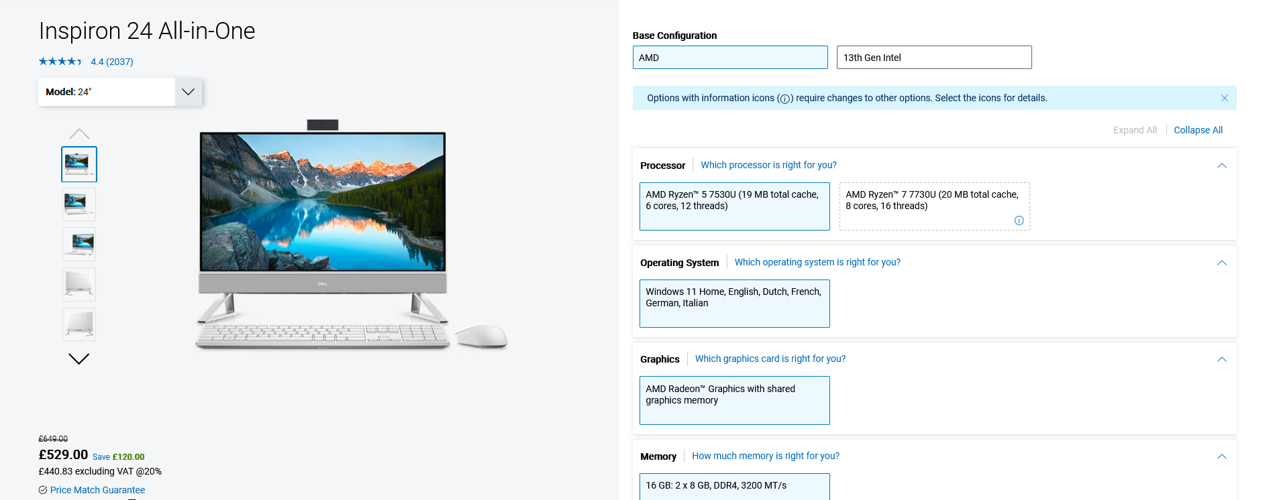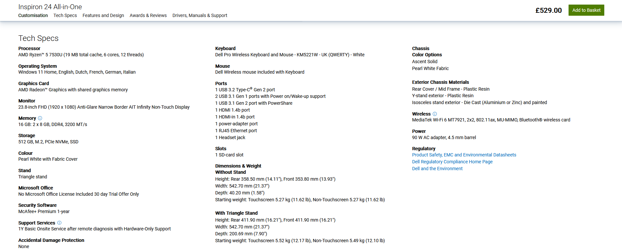

<https://www.dell.com/en-uk/shop/desktop-computers/inspiron-24-all-in-one/spd/inspiron-24-5415-aio/cd541506>

A cheaper alternative would be this ACER Aspire All-in-One; I would still strongly suggest an All-in-One for the secretary as this has the entire system inside the display. Based on the technical knowledge of the secretary and the use cases required, an All-in-One would more than fulfil the secretary’s needs.

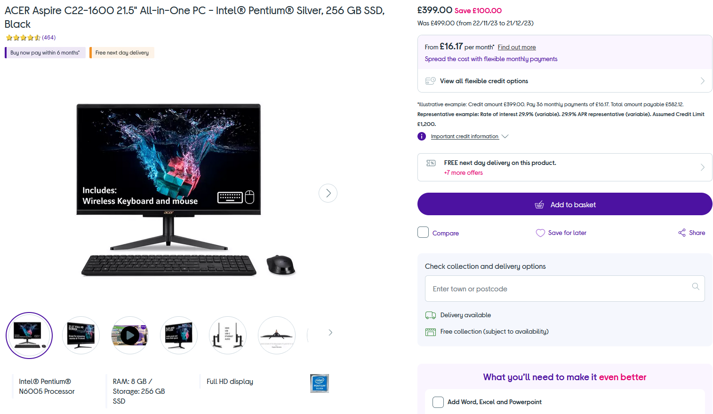

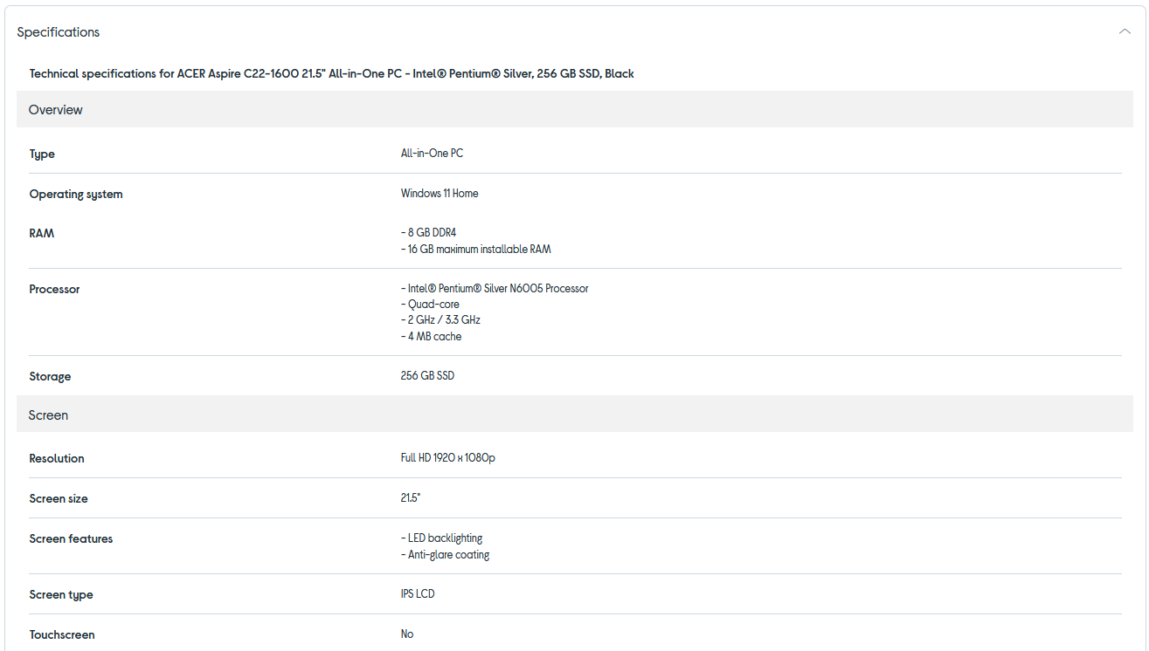

<https://www.currys.co.uk/products/acer-aspire-c221600-21.5-allinone-pc-intel-pentium-silver-256-gb-ssd-black-10239847.html>

## Resources and Materials

### Asset Log

|  |  |  |  |  |  |  |  |
| --- | --- | --- | --- | --- | --- | --- | --- |
| File Name | File Type | File Ext. | File Size | File Resolution | File Origin | Description | Example |
| logo | Image | PNG | 240KB | 1024x1024 | AI-generated | Sample logo based on Scottish Rugby logo |  |
| star | Image | PNG | 14KB | 512x512 | <https://www.flaticon.com/free-icon/star_616489?term=star&page=1&position=5&origin=style&related_id=616489> Free for personal and commercial use by attributing Freepik | Transparent image of a star |  |

### Hardware

* Personal laptop.
  + Acer Swift 3 Laptop.
  + 8GB DDR4 RAM.
  + AMD Ryzen 5 4500U with Radeon Graphics 2.38 GHz.
  + 64-bit operating system, x64-based processor.
  + Wi-Fi 6E compatibility.
  + Microsoft Windows 10 Version 22H2.
  + Built-in keyboard.
  + Built-in display (14” FHD IPS Display).
  + MX Master 3S computer mouse.
* Secure internet access (various networks).
* Extra displays when available (various monitors/displays).

### Software

#### System Environment

* Operating System: Microsoft Windows 10 Version 22H2.
* Browser: Mozilla Firefox.
* Search Engine: Google Chrome.

#### Planning

* Documentation: Microsoft Office.
* Project Plan: Trello.
* Notetaking: Notion.
* Wireframes: Ninja Mock.
* Miscellaneous Diagrams: draw.io.
* UML Diagrams: Visual Paradigm.
* ERD Diagrams: Visual Paradigm.

#### Development

* Development Environment: Visual Studio UWP.
* Database: Microsoft Azure Database (online).
* Research and Issues: Microsoft Documentation
* Research and Issues: Stack Overflow
* Research and Issues: ChatGPT.

# Project Plan

## Production of Plan

This preliminary plan outlines the required tasks and the schedule to complete them. These tasks could change, or new tasks might develop. The user stories are used to create tasks required in the product backlog; these tasks then get grouped in task blocks and placed in the sprint backlog, ready to be moved to the current sprint. Once completed in the current sprint, they get moved to complete if they don’t require testing; if they do, they get pushed to the test sprint to get tested and finally moved to completed tests when thoroughly tested.

**Inception of tasks and tasks completed as of 07/02/2024.**

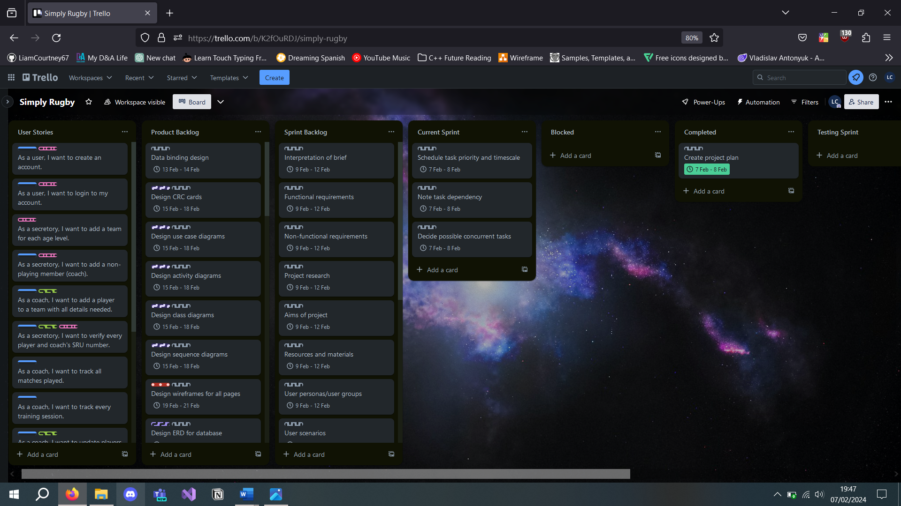

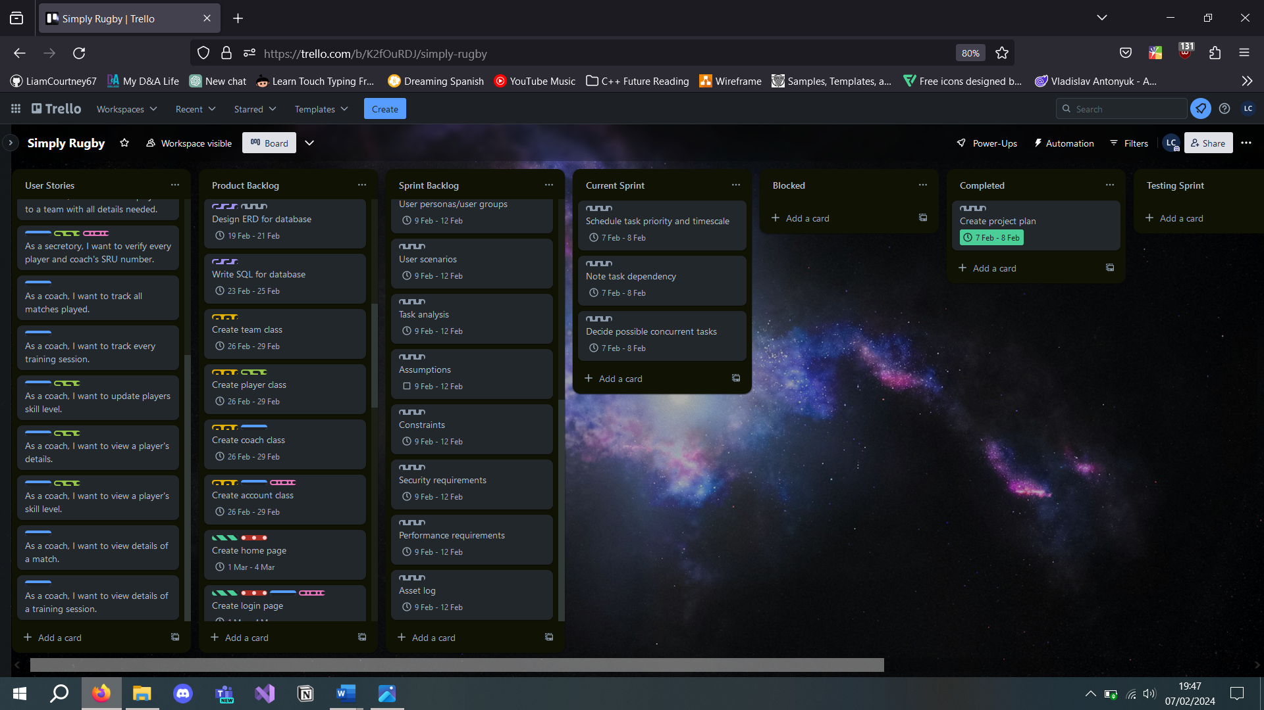

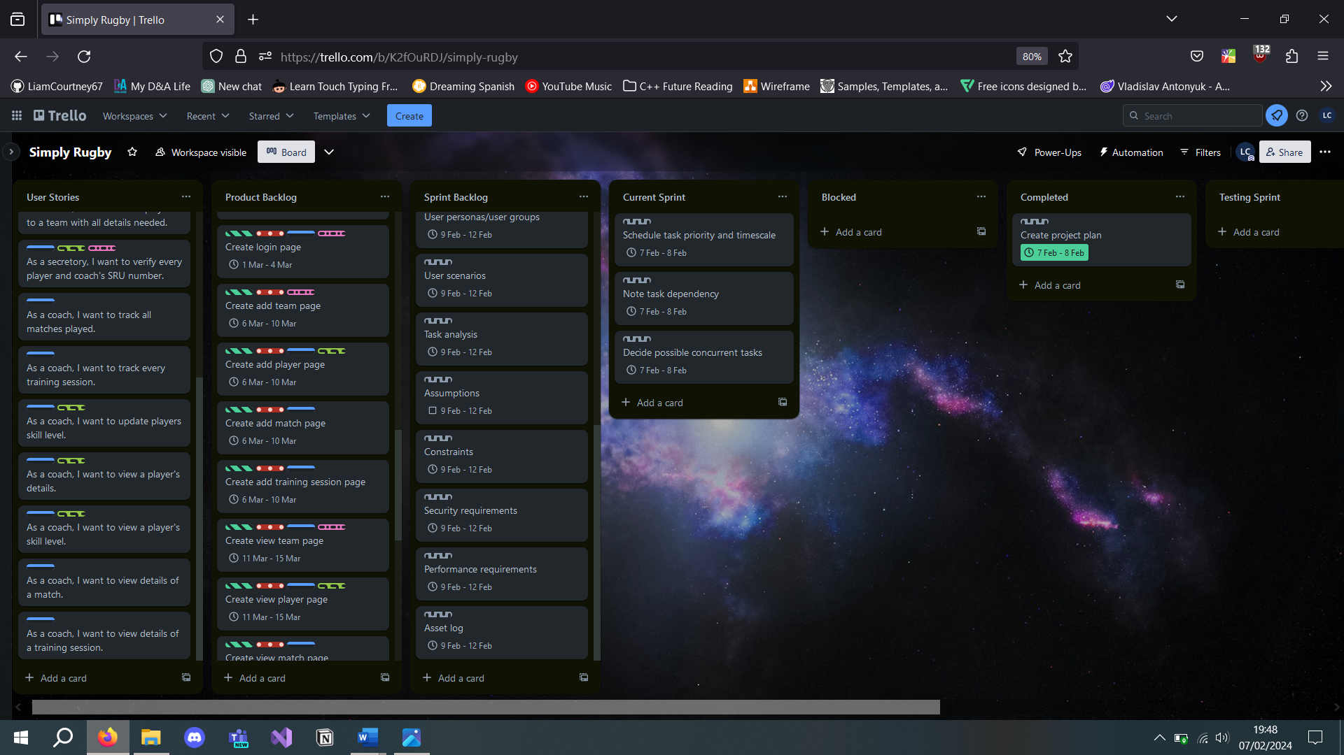

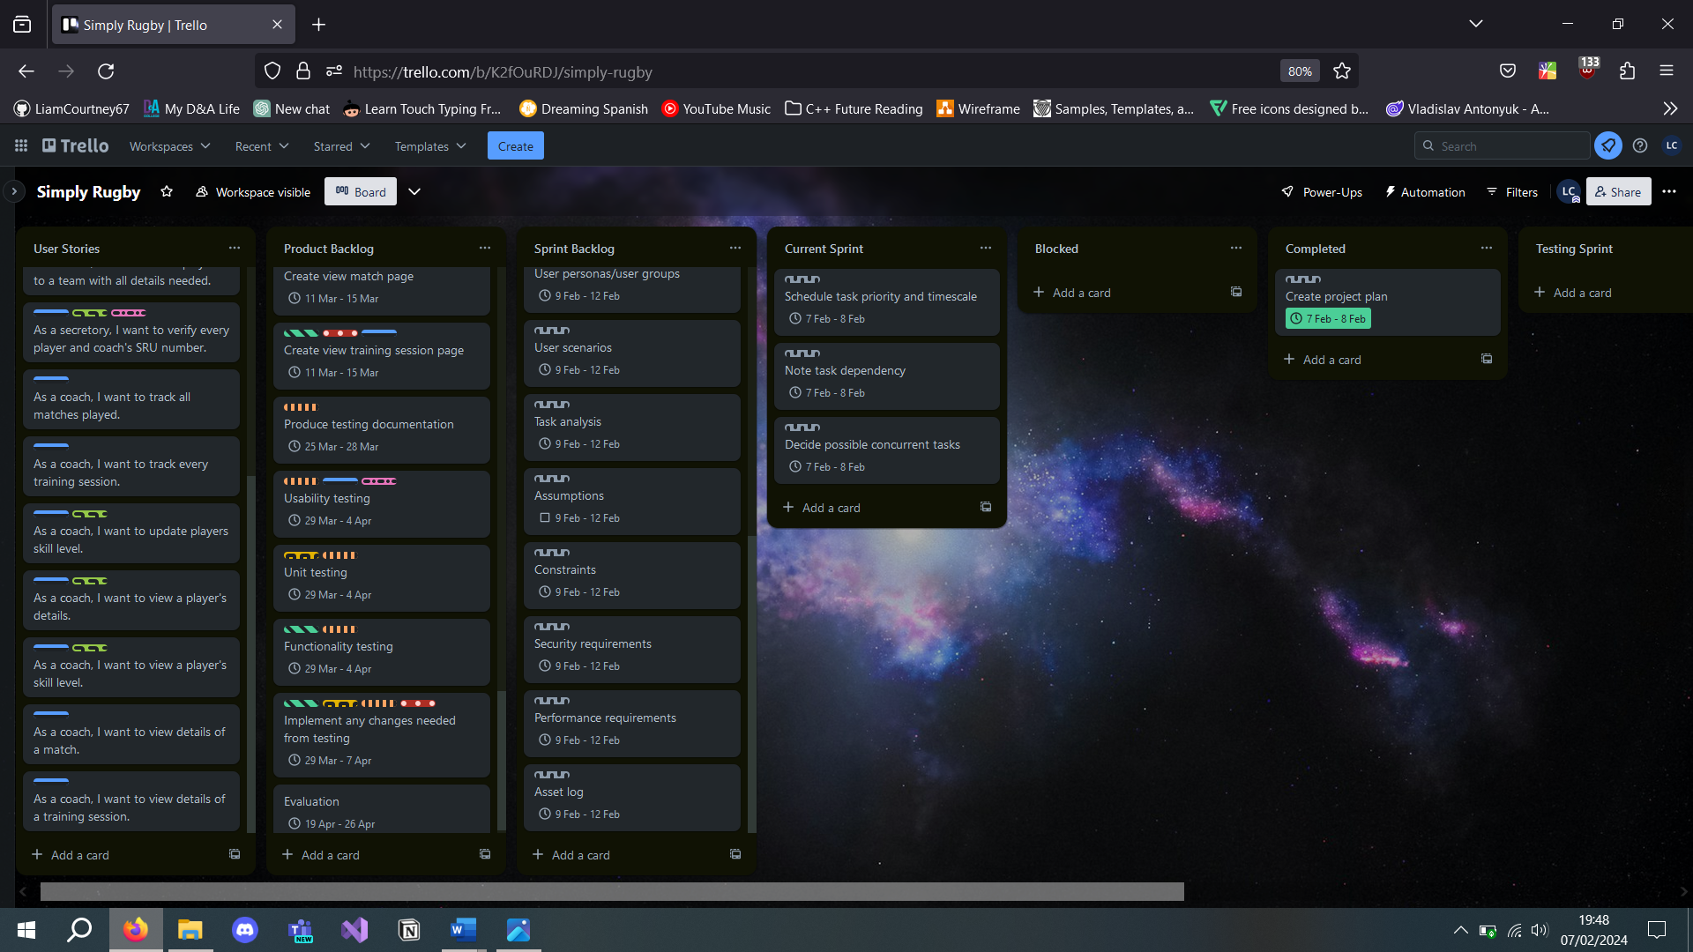

**Tasks completed as of 12/02/2024.**

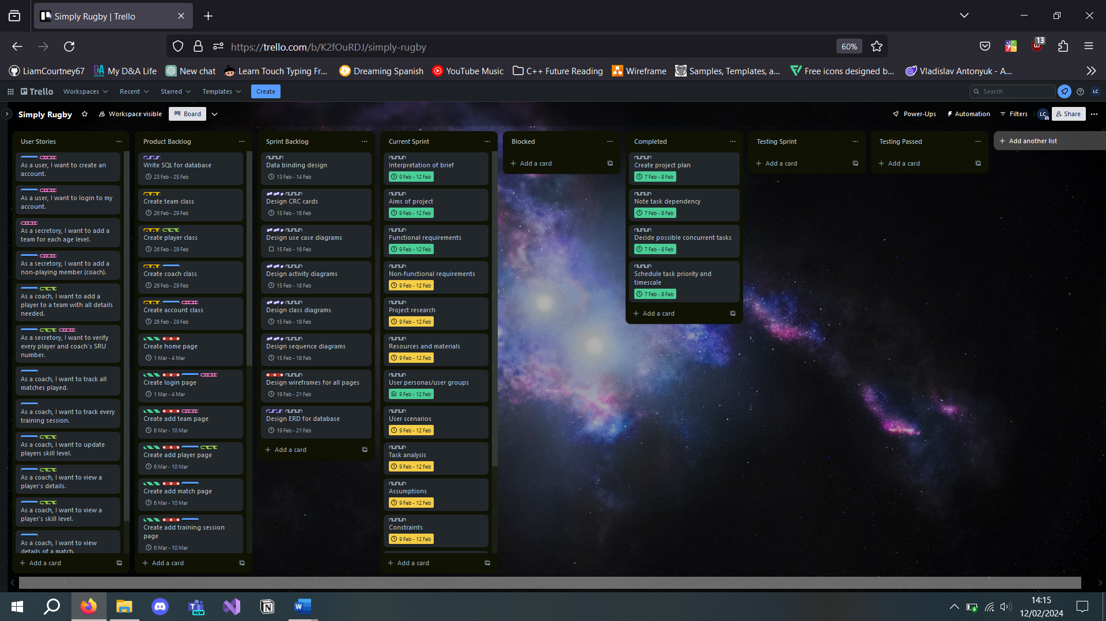

**Tasks completed as of 19/02/2024.**

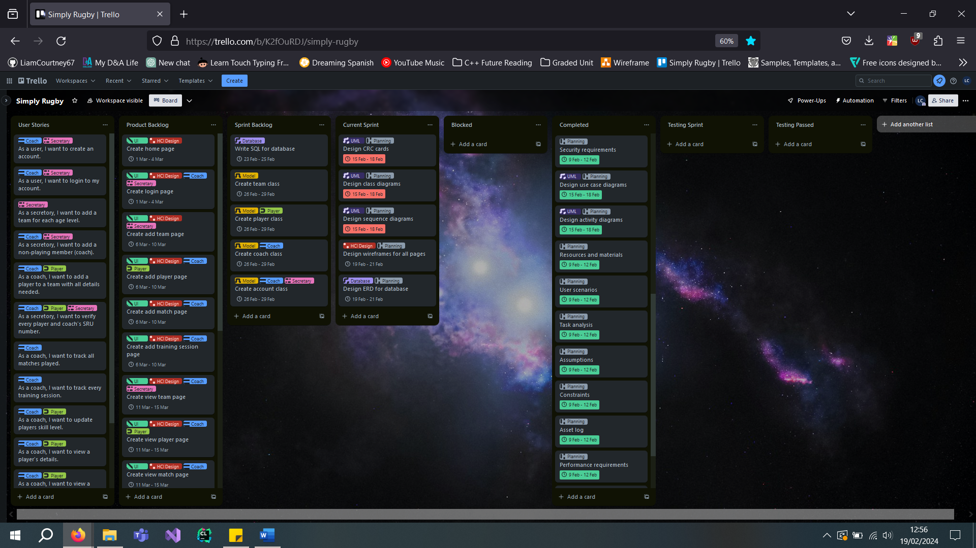

**Tasks were completed as of 21/02/2024, but delays on class diagrams blocked the ERD and data binding diagram.**

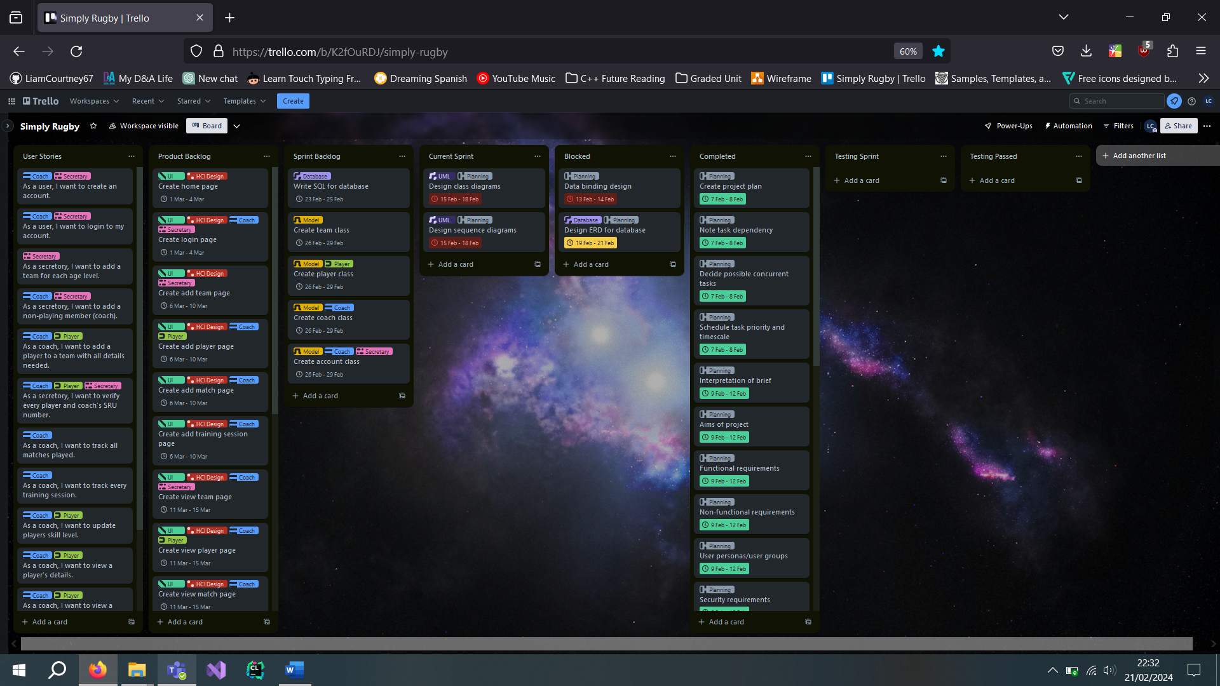

**Tasks were completed as of 23/02/2024; this marks the end of the planning phase.**

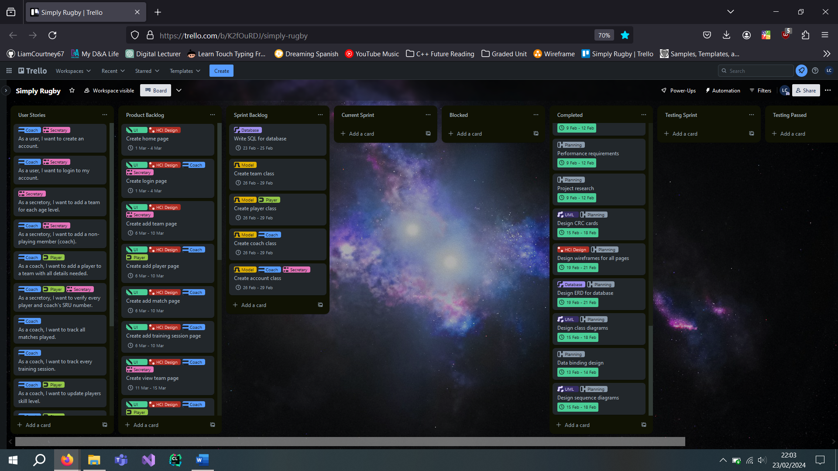

## Tasks

### Planning

This visual represents task concurrency and dependency; tasks on the same layer can be done concurrently; tasks are dependent on the tasks above and cannot be completed before the previous tasks have been completed.

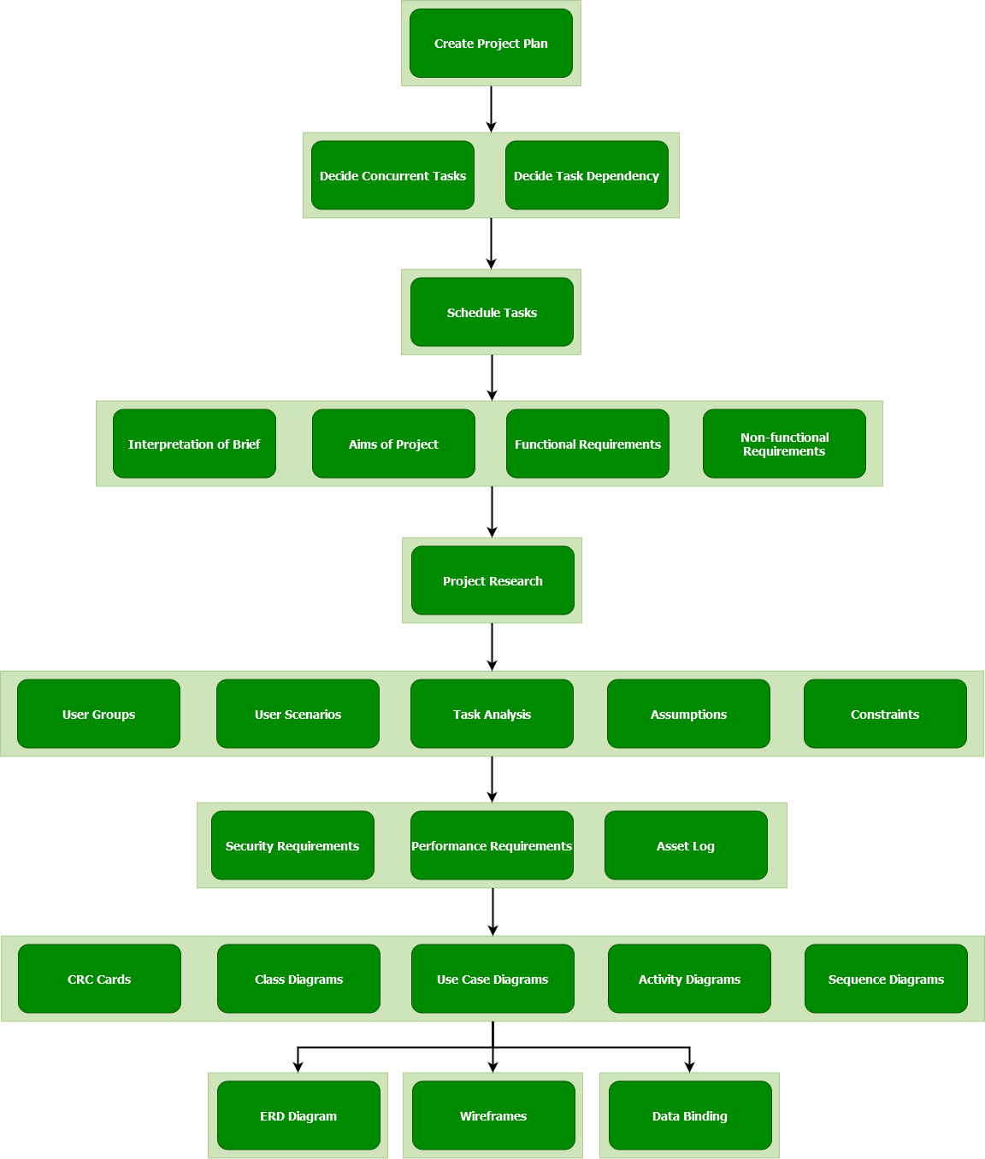

### Implementation

All the previous planning tasks must be completed before any implementation tasks can be completed. The same key of task concurrency and dependency applies here.

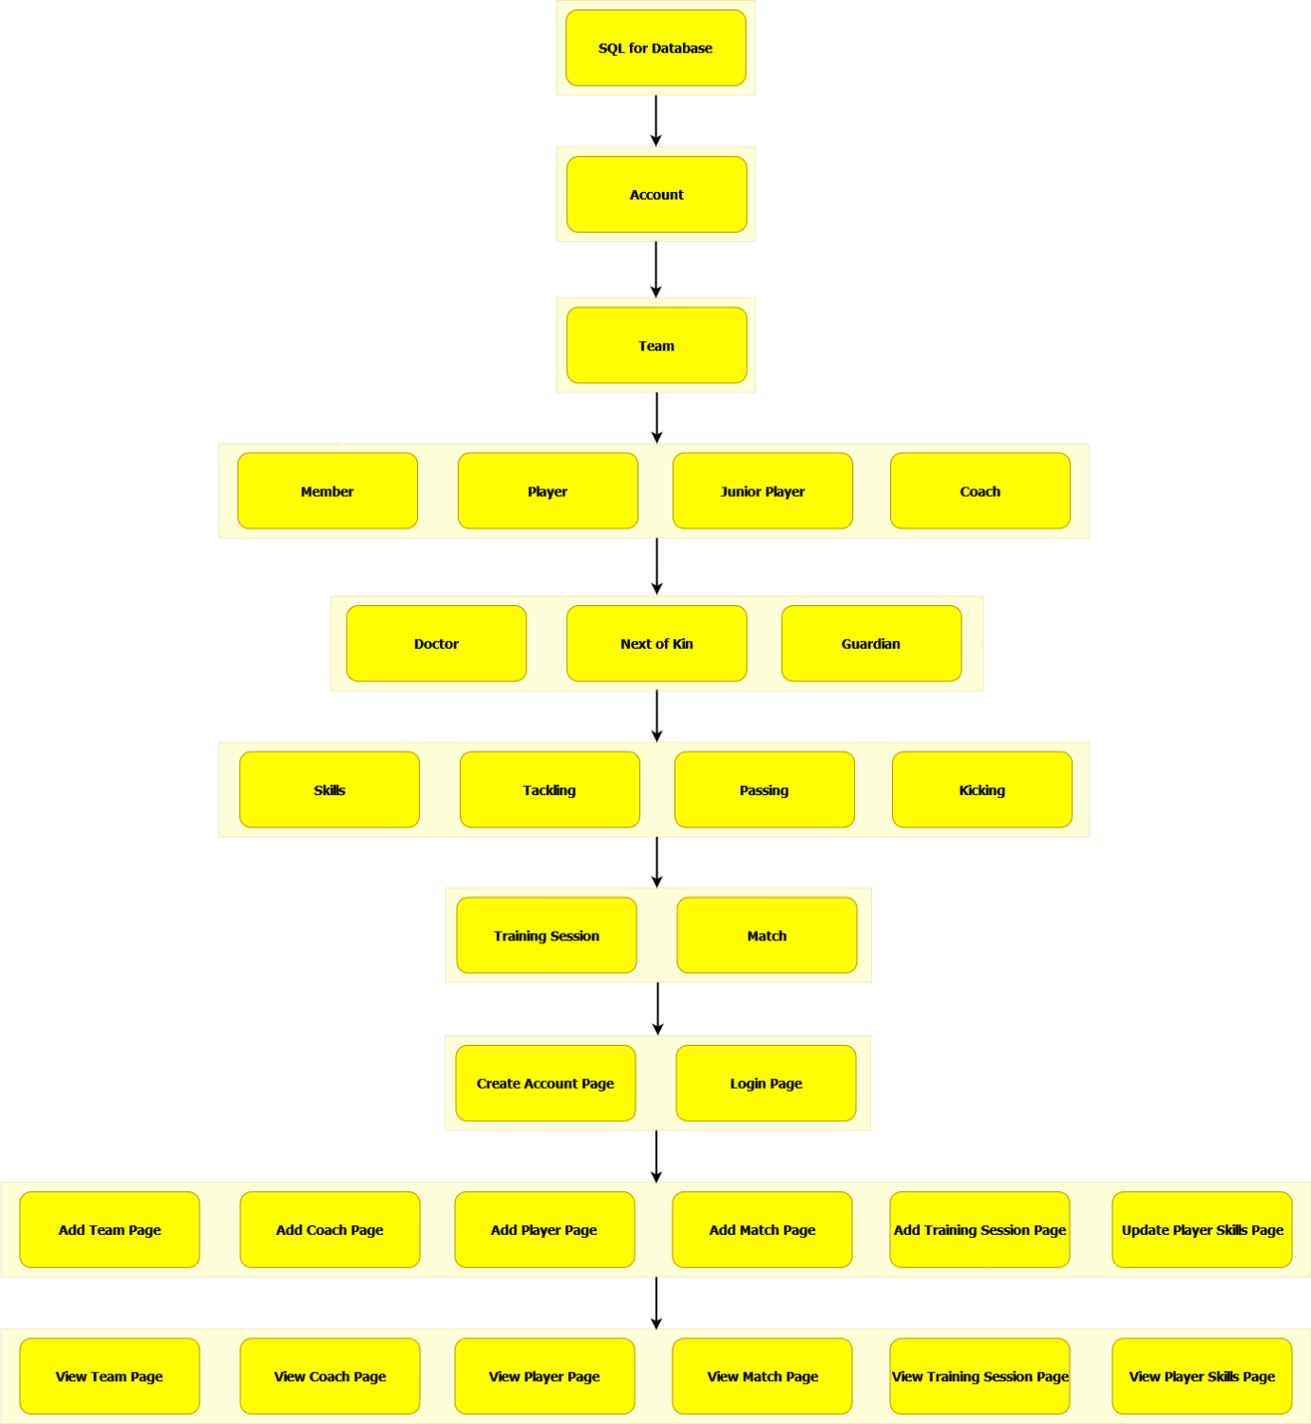

### Testing

Before any testing tasks can be completed, all the previous planning and implementation tasks need to be completed. The same key of task concurrency and dependency applies here.

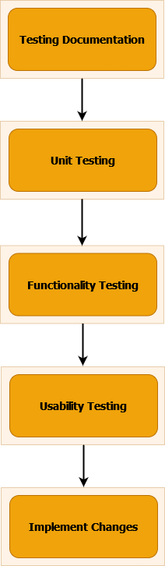

### Evaluation

Before any evaluation tasks can be completed, all the previous planning, implementation, and testing tasks need to be completed. The same key of task concurrency and dependency applies here.

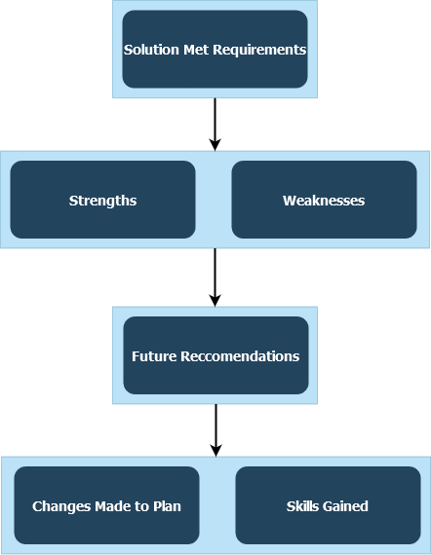

## Schedule

Blocks of tasks are grouped here; more details of individual tasks are in the Trello board.

|  |  |  |  |  |
| --- | --- | --- | --- | --- |
|  | **Planning** | **Implementation** | **Testing** | **Evaluation** |
| *Week 1* | Project Plan and Analysis of Project Brief |  |  |  |
| *Week 2* | UML and ERD Diagrams |  |  |  |
| *Week 3*  *Planning Due* | Buffer Week | Write SQL for the Database |  |  |
| *Week 4* |  | Create Models and Start on Pages |  |  |
| *Week 5* |  | Create ‘Add’ Pages |  |  |
| *Week 6* |  | Create ‘View’ Pages |  |  |
| *Week 7* |  | Scope Week |  |  |
| *Week 8*  *Finish Implementation* |  | Buffer Week | Create Testing Documentation and Start Testing |  |
| *Week 9* |  |  | Usability, Functional, Unit Testing and Implement Changes Needed |  |
| *Week 10* |  | Buffer Week | Buffer Week |  |
| *Week 11*  *Implementation and Testing Due* |  | Buffer Week | Buffer Week |  |
| *Week 12* |  |  |  | Start Evaluation |
| *Week 13* |  |  |  | Finish Evaluation |
| *Week 14*  *Evaluation Due* |  |  |  | Buffer Week |

## Milestones and Deliverables

### Planning

* **Project Planning**
  + Create a project plan, considering:
    - Task concurrency.
    - Task dependencies.
  + Schedule tasks based on the project plan.
* **Project Brief Analysis**
  + Interpretation of the project brief.
  + Define the aims of the project.
  + Identify functional requirements.
  + Identify non-functional requirements.
* **Project Research**
  + Analyse User Groups.
  + Develop user scenarios.
  + Perform task analysis.
  + State assumptions.
  + Define constraints.
* **Requirements Specification**
  + Determine security requirements.
  + Establish performance requirements.
* **Resources and Materials**
  + Create an asset log.
* **Design Phase**
  + Develop CRC (Class-Responsibility-Collaborator) Cards.
  + Create class diagrams.
  + Design use case diagrams.
  + Design activity diagrams.
  + Create sequence diagrams.
  + Construct ERD (Entity-Relationship Diagram) for database modelling.
  + Create wireframes for UI/UX design.
  + Design data binding diagram.

### Implementation

* **Database Creation**
  + Write SQL for the database.
* **User Account**
  + Create an Account class.
  + Create AdminAccount class.
  + Create CoachAccount class.
* **Creation of Models**
  + Create a Team model.
  + Create a Training Session model.
  + Create a Match model.
  + Create a Member model.
    - Create Coach Player model inheriting from Member.
    - Create Player model inheriting from Member.
      * Create Doctor as a helper class for the Player.
      * Create NextOfKin as a helper class for player.
      * Create JuniorPlayer model inheriting from Player.
        + Create a Guardian class inheriting from NextOfKin as a helper class for JuniorPlayer.
    - Create a Skills class to track a Member’s skills.
      * Create a Tackling class as a helper class for Skills.
      * Create a Passing class as a helper class for Skills.
      * Create a Kicking class as a helper class for Skills.
* **User Interface Components**
  + Implement a Login page based on the wireframe.
    - Implement a Create Account page based on the wireframe as a supplementary page to the Login page.
  + Implement an Add Team page based on the wireframe.
  + Implement an Add Coach page based on the wireframe.
  + Implement an Add Player page based on the wireframe.
  + Implement an Add Match page based on the wireframe.
  + Implement an Add Training Session page based on the wireframe.
  + Implement a View Team page based on the wireframe.
  + Implement a View Coach page based on the wireframe.
  + Implement a View Player (and Player Skills) page based on the wireframe.
  + Implement a View Match page based on the wireframe.
  + Implement a View Training Session page based on the wireframe.

### Testing

* **Testing Documentation**
  + Create unit testing documentation.
  + Create functionality testing documentation based on functional requirements.
  + Create usability testing documentation based on the users’ use cases.
* **Tests**
  + Perform unit tests.
    - Implement any changes as needed.
  + Perform functionality testing.
    - Implement any changes as needed.
  + Perform usability testing with appropriate users.
    - Implement any changes as needed.

### Evaluation

* **Personal Evaluation**
  + Did the solution meet the requirements?
  + Note:
    - Strengths.
    - Weaknesses.
  + Detail any future recommendations.
  + Document any changes from the original plan.
  + Note down any skills gained in the entire project.

## Main Tasks

The schedule and time requirements are elsewhere in the ‘Project Plan’ section.

* **Planning**
  + Project Planning
  + Project Brief Analysis
  + Project Research
  + Requirements Specification
  + Resources and Materials Acquisition
  + Design Phase
* **Implementation**
  + Database and Backend Development
  + User Interface Development
* **Testing**
  + Testing and Documentation
* **Evaluation**
  + Project Review and Reporting

## Resources

### Hardware

* Personal laptop.
  + Acer Swift 3 Laptop.
  + 8GB DDR4 RAM.
  + AMD Ryzen 5 4500U with Radeon Graphics 2.38 GHz.
  + 64-bit operating system, x64-based processor.
  + Wi-Fi 6E compatibility.
  + Microsoft Windows 10 Version 22H2.
  + Built-in keyboard.
  + Built-in display (14” FHD IPS Display).
  + MX Master 3S computer mouse.
* Secure internet access (various networks).
* Extra displays when available (various monitors/displays).

### Software

#### System Environment

* Operating System: Microsoft Windows 10 Version 22H2.
* Browser: Mozilla Firefox.
* Search Engine: Google Chrome.

#### Planning

* Documentation: Microsoft Office.
* Project Plan: Trello.
* Notetaking: Notion.
* Wireframes: Ninja Mock.
* Miscellaneous Diagrams: draw.io.
* UML Diagrams: Visual Paradigm.
* ERD Diagrams: Visual Paradigm.

#### Development

* Development Environment: Visual Studio UWP.
* Database: Microsoft Azure Database (online).
* Research and Issues: Microsoft Documentation
* Research and Issues: Stack Overflow
* Research and Issues: ChatGPT.

# Analysis and Design of Solution Plan

## Business Model

The following diagrams were produced using Visual Paradigm’s UML Diagram software.

### Use Case Diagram

This is more of a high-level look at the system. These are the primary use cases for the secretary and coaches. The secretary has the power as an administrator to perform all the same tasks as the coaches, but these would be performed as if they were a coach. This functionality is required in the event of no coaches from a team being able to access the system.

The secretary is usually only responsible for creating teams and adding coaches to their appropriate team. The coaches are responsible for all the team management, adding players, matches, and training sessions. There is also an additional use case for managing a player's skill development.

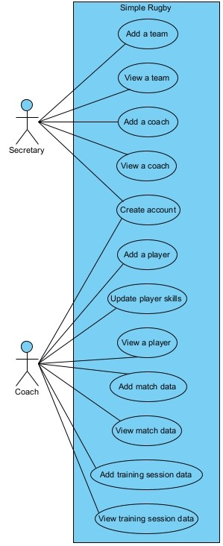

This is a more detailed depiction of the use cases involved in this system. This diagram shows the same use cases as before, but this goes into more depth about all the possible use cases. Editing and deleting teams, coaches, players, matches, and sessions is possible. This functionality gives users an easier experience, allowing a solution for human errors. Members’ details may also change during a season, so this accounts for that, as well as members leaving the club. There are also more detailed use cases on player skill development, showing the ability to view and edit player’s skills.

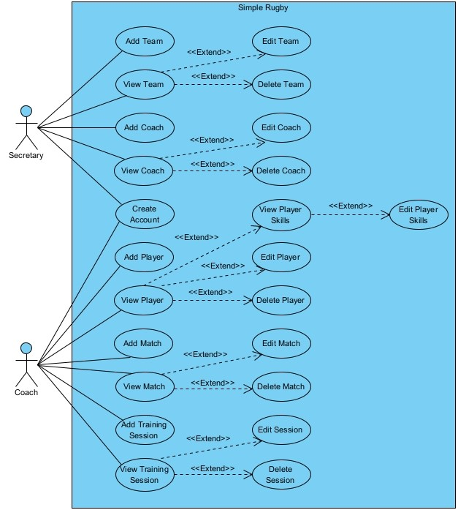

### Activity Diagram

This activity diagram shows the system's flow for all users, including the secretary and coaches. The process begins with the application being opened; the user will be prompted with a login screen; if they don’t have an account, they can navigate to the Create Account page. Once logged in, the system will be different depending on the access level of the user’s account. The secretary, as an admin, has access to the entire system, but they will mainly only be adding teams and coaches to the system. If a team does not have a dedicated user for the system, the secretary can act on this team’s behalf, behaving as a coach. The coach will only have access to their designated team; they will have options to add or view players, matches, or sessions. The coaches also have the option of updating a player’s skill development. After completing any task, all users can close the application or continue with another task.

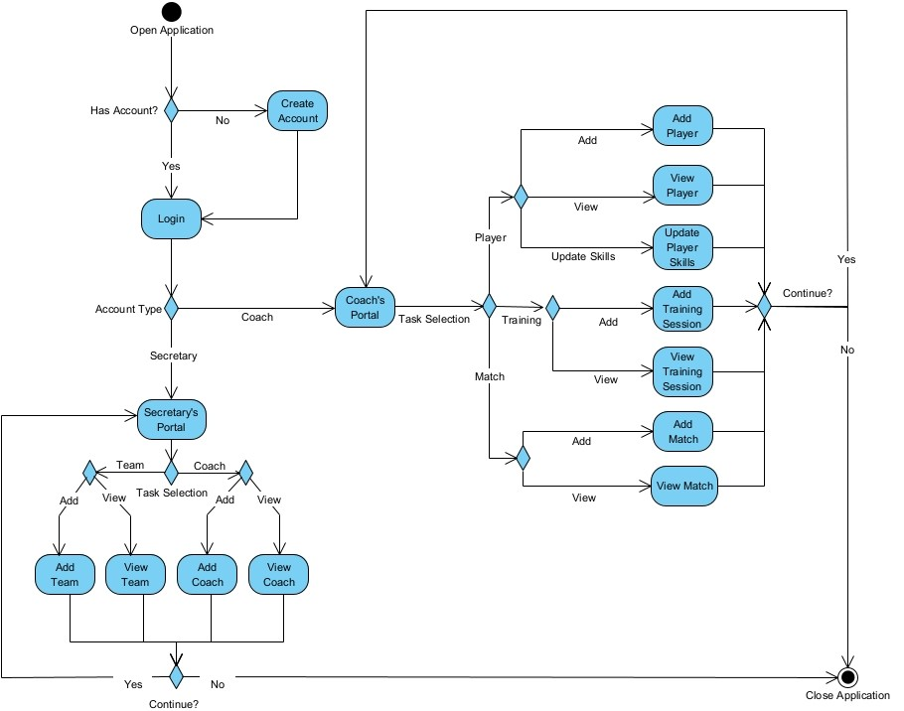

### CRC Cards

**See supported PDF (CRC Cards.pdf).**

The creation of CRC cards provides a high-level outlook on the possible classes, attributes, behaviours, and relationships. Through this method, it was found that members have a lot of shared attributes, leaving the possibility of grouping this information. It was also found that some information, such as the doctor, next of kin, and guardians relating to the players, could be broken up into their own classes. Skill development was also broken up into separate classes and made available to all members to allow the ability for coach’s skill development in the future. The same thought process was used for the rest of the classes to create an outline for future class diagrams.

### Class Diagram

A more detailed class diagram was possible using the analysis from the CRC cards. This showed classes' shared attributes and behaviours that could be pulled from a member class. Information was also divided into separate classes for a more straightforward development process, such as the doctor, next of kin, and guardian. Accounts based on the user’s access level were added to the diagram; a secretary as an admin would have access to every team in the system, whereas a coach would only have access to their own team’s information to align with GDPR and the Data Protection Act. Relationships and multiplicity among classes were made clear with Visual Paradigm’s built-in tools. The design of this class diagram provides a clear blueprint for the system's development process. Note that the classes do not show database pushing and pulling for simplicity; it is implied whenever something is added, it is also added to the database and pulled down at the start of the application.

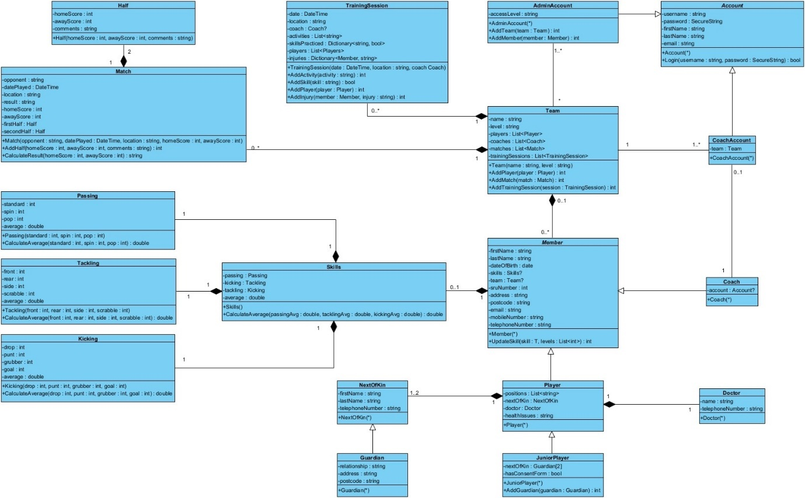

### Sequence Diagrams

Sequence diagrams depict the lifespan of objects and how they interact with each other. The following diagrams represent the use cases of the system for all users, the secretary (admin), and coaches. These diagrams round out the overall perspective on the system's architecture and operations.

#### All Users

Create Account:

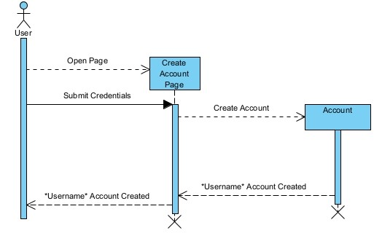

Login:

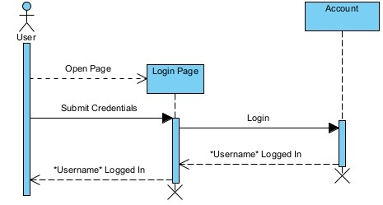

View Team:

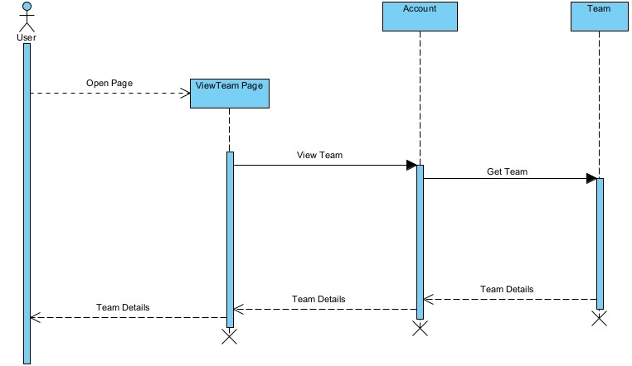

#### Secretary

Add Team:

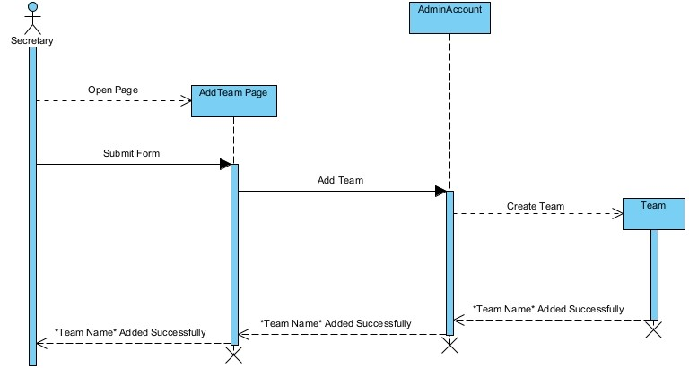

Add Coach:

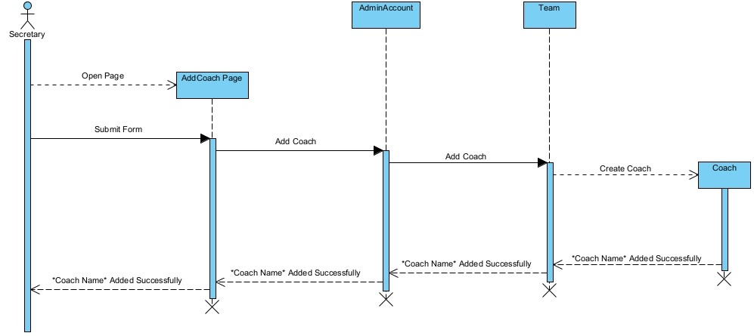

#### Coach

Add Player:

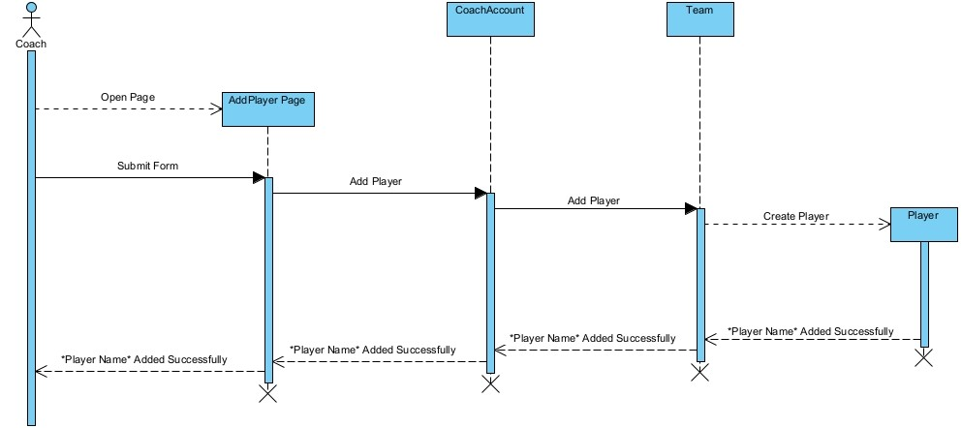

Add Match:

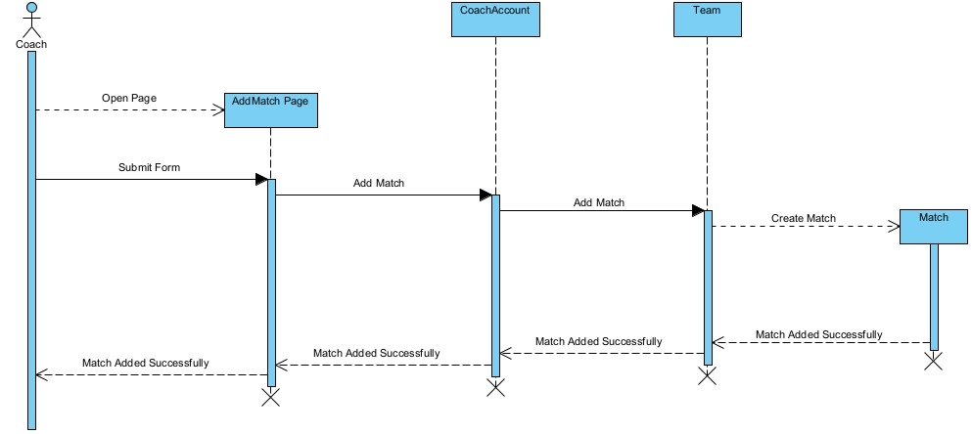

Add Training Session:

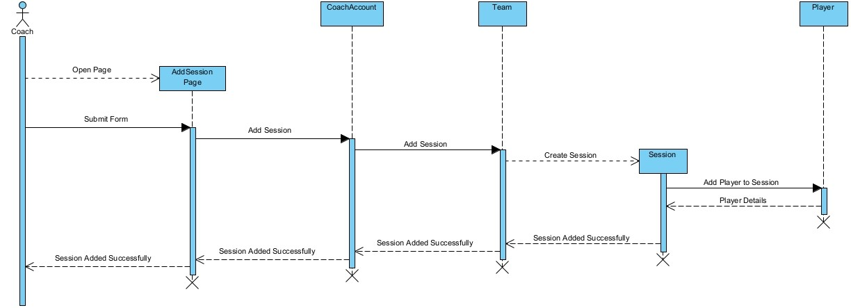

View Player:

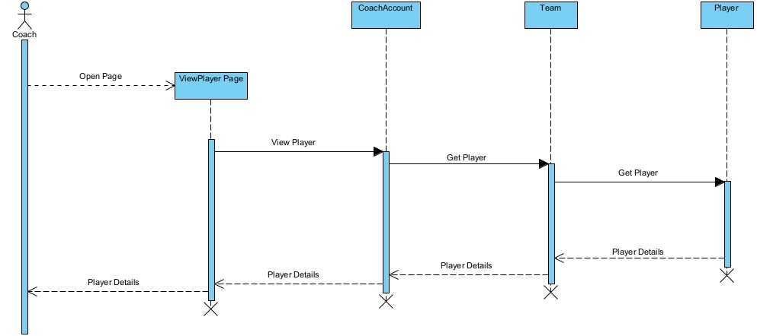

View Match:

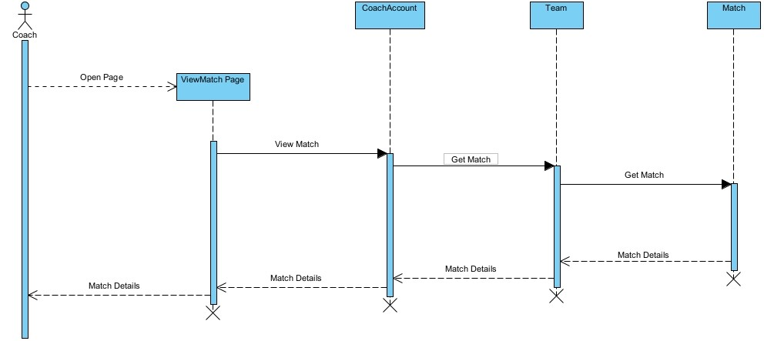

View Training Session:

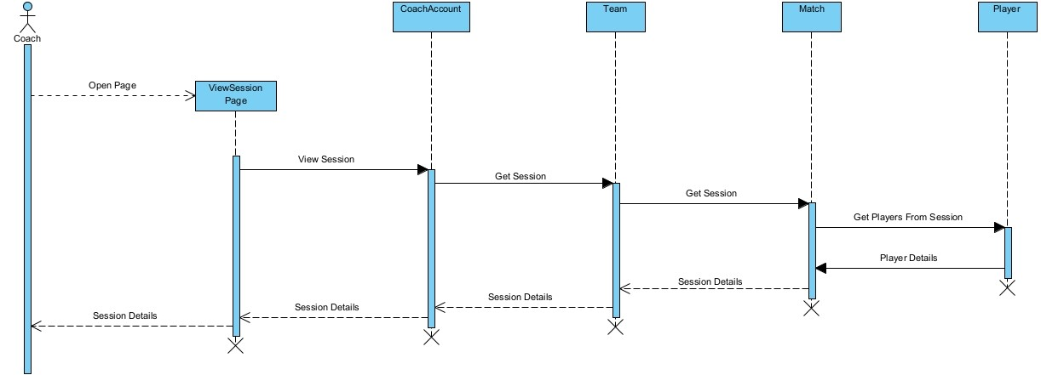

View and Edit Player Skills:

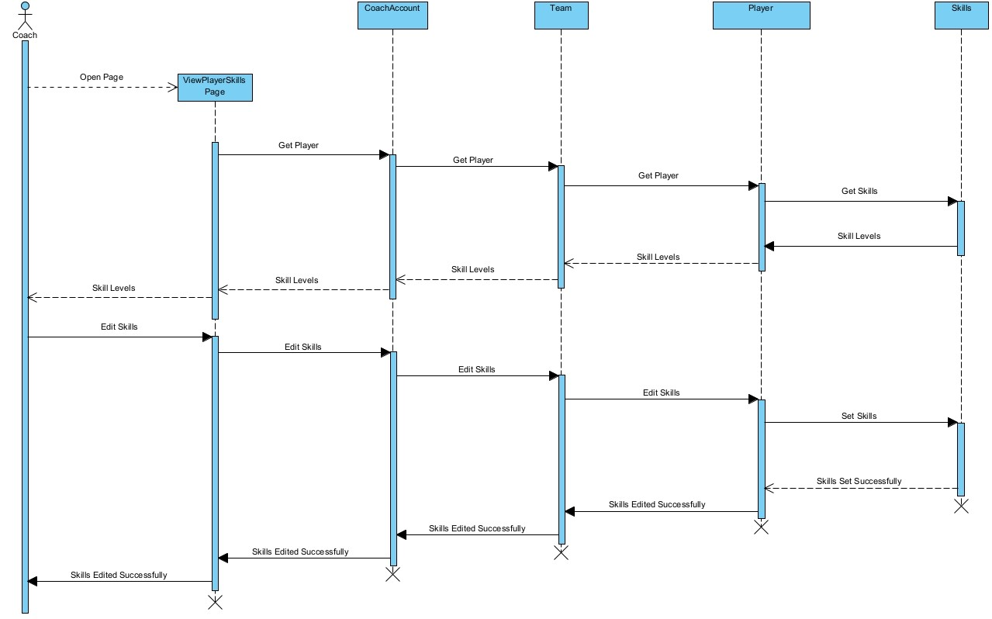

### ERD

The entity relationship diagram (ERD) provides a blueprint for the database's inception. This is based on the final class diagram, which shares the same relationships and multiplicity. Most of the ERD follows closely with the class diagram; in some cases, ‘joining tables’ were required where lists were present in the class diagram. This is apparent with the training session’s activities, skills practised, and players present. Columns in bold are the table’s primary keys or unique identifiers, columns in italics are foreign key references to other tables, columns with a red ‘U’ are required to be unique for each entry, such as a team name, finally, columns with a white ‘N’ are nullable this means an entry isn’t required; such is the case with a training session’s coach or a player’s health issues as this won't always be needed due to a guest coach or a player having no health issues.

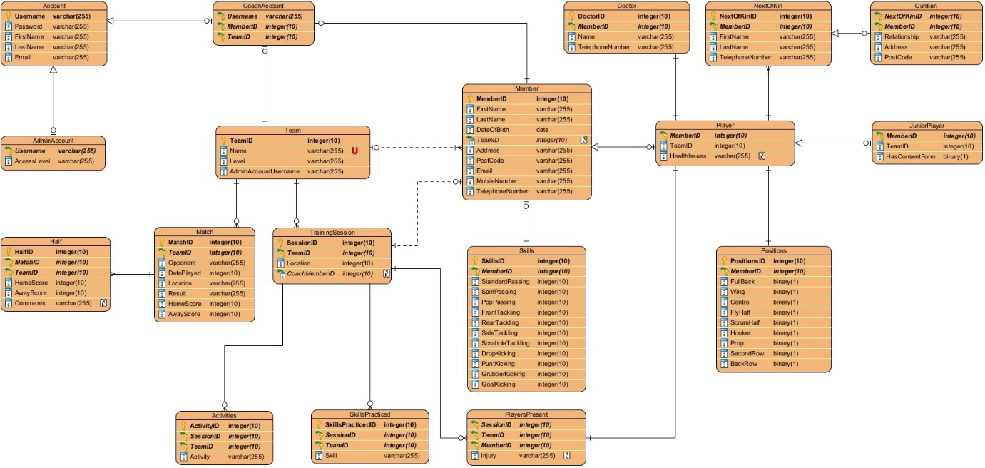

## View Model

### Wireframes

The following wireframes were produced using Ninja Mock’s online wireframing tool.

#### Justification

These designs are based on “Jakob Nielsen's 10 general principles for interaction design” (Nielsen, 2024). The analysis of these principles will be shown individually to demonstrate the thought process behind all these designs. The core design of all the pages is the same: an ‘Add’ page is a form, and a ‘View’ page is essentially a table. The only exceptions are the home page, which still uses the same design as a ‘tutorial’ for new users, and the player skills page, which has been based on a bestselling sports game design but still follows all the following principles.

#### Visibility of System Status

“The design should always keep users informed about what is going on through appropriate feedback within a reasonable amount of time” (Nielsen, 2024). This is achieved through the success or error message area under every form; this provides information on the current process, for example, ‘Adding John Smith’ and then ‘John Smith Added Successfully’.

#### Match Between the System and the Real World

“The design should speak the users' language. Use words, phrases, and concepts familiar to the user rather than internal jargon. Follow real-world conventions, making information appear in a natural and logical order” (Nielsen, 2024). Naturally, this was the case by default, such as using terms such as player, coach, team, match, or training session and using the correct positions and skills appropriate to a rugby team.

#### User Control and Freedom

“Users often perform actions by mistake. They need a clearly marked ‘emergency exit’ to leave the unwanted action without having to go through an extended process” (Nielsen, 2024). By default, a player, coach, etc., isn’t added until the form is submitted, allowing any mistakes to be corrected during the process of the form. There are clearly defined ‘Edit’ and ‘Delete’ buttons on the viewing pages to allow any unnoticed mistakes to be corrected after the fact.

#### Consistency and Standards

“Users should not have to wonder whether different words, situations, or actions mean the same thing. Follow platform and industry conventions” (Nielsen, 2024). Consistency within the application is clear, as well as industry standards. Every ‘Add’ and ‘View’ page is consistent with its design and elements following a form or table view blueprint. Industry standards are followed in the design of forms, including the ‘Login’ and ‘Create Account’ pages. The idea is that anyone can understand the page the first time of use, either by the consistency between pages or the industry standard.

#### Error Prevention

“Good error messages are important, but the best designs carefully prevent problems from occurring in the first place. Either eliminate error-prone conditions or check for them and present users with a confirmation option before they commit to the action” (Nielsen, 2024). The only errors that can arise from this system are from the ‘Add’ pages when a user is completing a form. Some prevention is possible, such as only adding a player to the coach’s team responsible for them and avoiding errors in the system's organisation. Boolean values, such as true or false, are also used for a player’s possible positions, as well as calculating the result from the score, avoiding unnecessary string inputs. Some prevention is possible by only allowing the required data type as input, such as a number, date, or time, but the rest of the validation will be done through backend code.

#### Recognition Rather than Recall

“Minimize the user's memory load by making elements, actions, and options visible. The user should not have to remember information from one part of the interface to another. Information required to use the design (e.g. field labels or menu items) should be visible or easily retrievable when needed” (Nielsen, 2024). This is achieved by having clearly defined headings, placeholder text, buttons, and dropdowns. The navigation is also always visible, so the user can easily spot it without remembering how to open it from somewhere.

#### Flexibility and Efficiency of Use

“Shortcuts — hidden from novice users — may speed up the interaction for the expert user so that the design can cater to inexperienced and experienced users. Allow users to tailor frequent actions” (Nielsen, 2024). This is one of the only heuristics that doesn’t apply to this system due to the system's straightforwardness and limited use cases. If any further development takes place in the future or more complex use cases arise, efficient shortcuts will be added.

#### Aesthetic and Minimalist Design

“Interfaces should not contain information that is irrelevant or rarely needed. Every extra unit of information in an interface competes with the relevant units of information and diminishes their relative visibility” (Nielsen, 2024). The designs of these pages only show the necessary information to create or view a player, coach, etc., in a visually appealing and functional way. Where extra information is required, such as the player skill development, a subpage was made to focus on this additional information.

#### Help Users Recognize, Diagnose, and Recover from Errors

“Error messages should be expressed in plain language (no error codes), precisely indicate the problem, and constructively suggest a solution” (Nielsen, 2024). The planned error messages for this system will use basic terms all users would understand, such as “Check Internet Connection”, “Guardian’s Relationship Cannot Contain Any Numbers or Special Characters”, and “Password is Incorrect”. These messages give the user an apparent cause of any errors and assist in correcting any issues.

#### Help and Documentation

“It’s best if the system doesn’t need any additional explanation. However, it may be necessary to provide documentation to help users understand how to complete their tasks” (Nielsen, 2024). These designs aim to be as intuitive as possible, but documentation will be made available to users in case of confusion. The home page provides a walkthrough of the core elements of the application, but further documentation will be created after the system has been developed. This can be used as a reference for any issues or problems with the system.

#### All Users’ Pages

The home page is a functionless page with the sole purpose of acting as a tutorial for new users to understand the system's main elements.

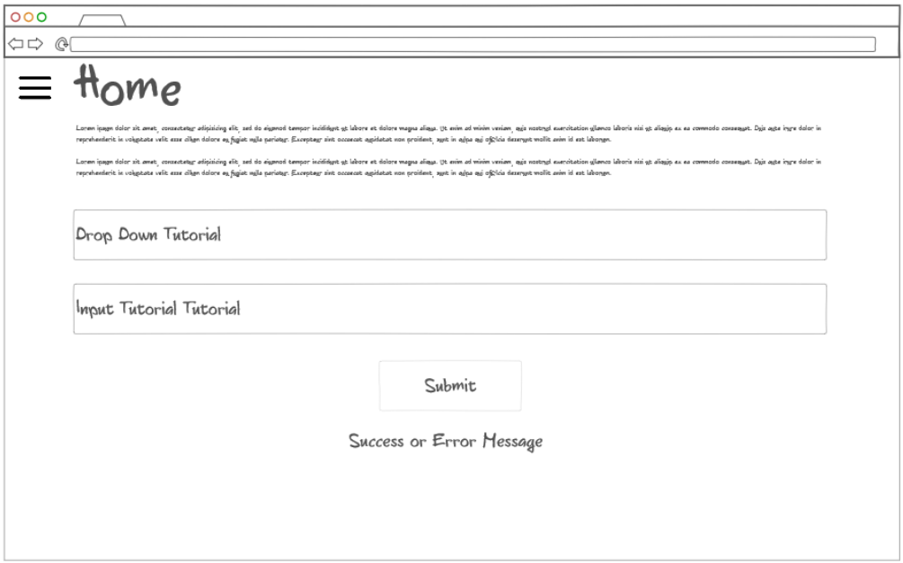

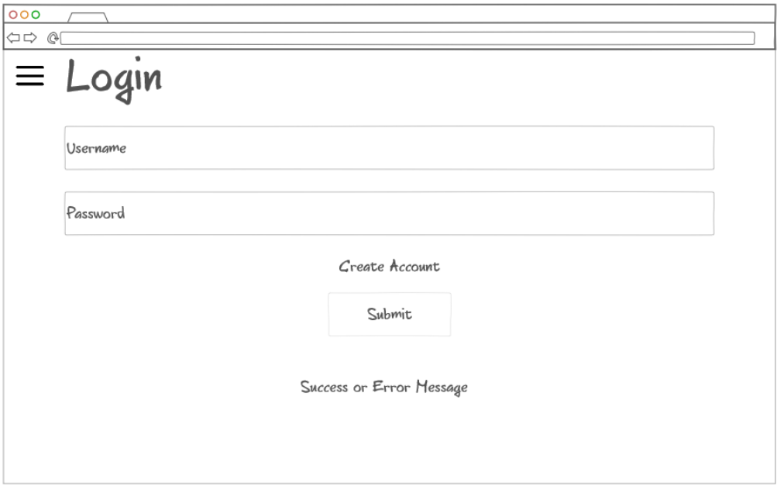

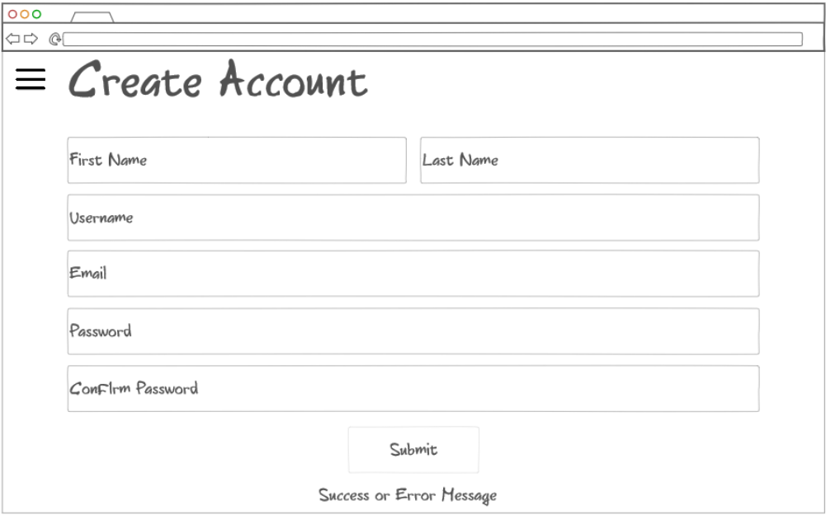

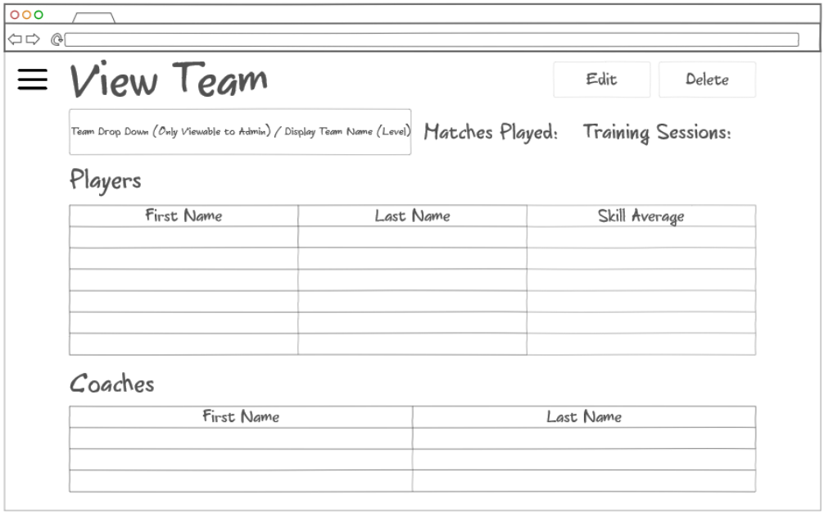

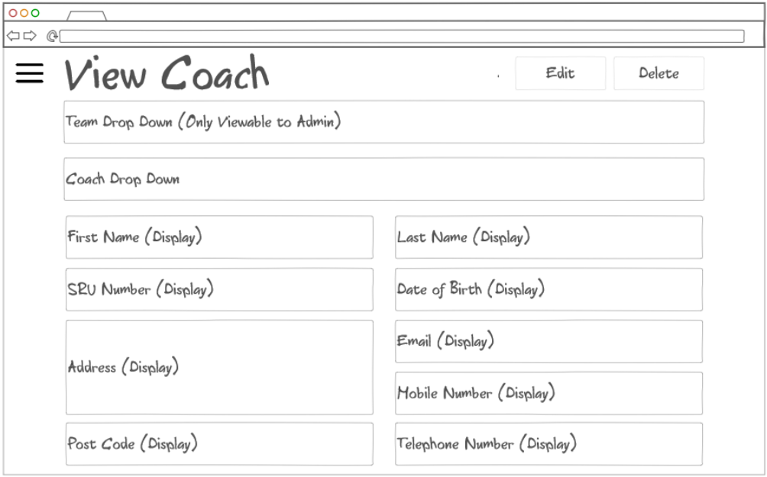

#### Secretary’s Pages (Admin)

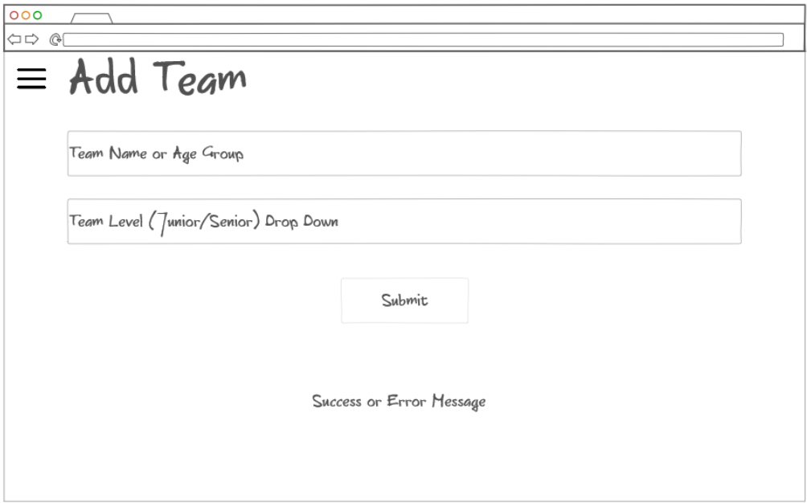

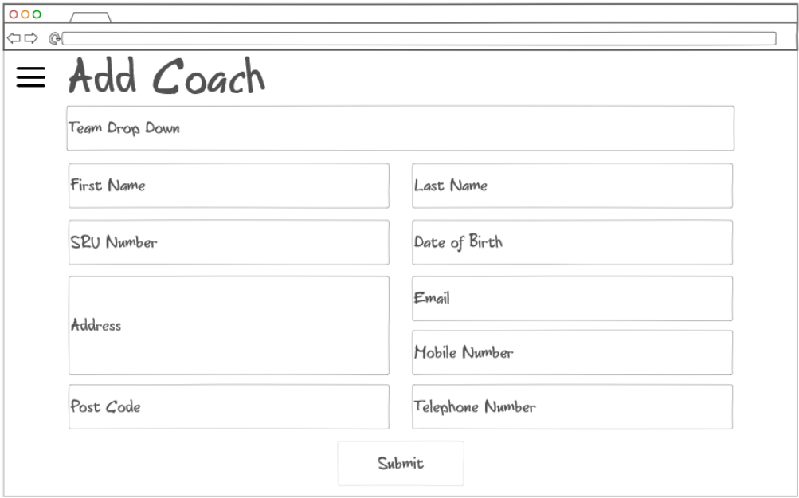

#### Coach’s Pages

##### Player

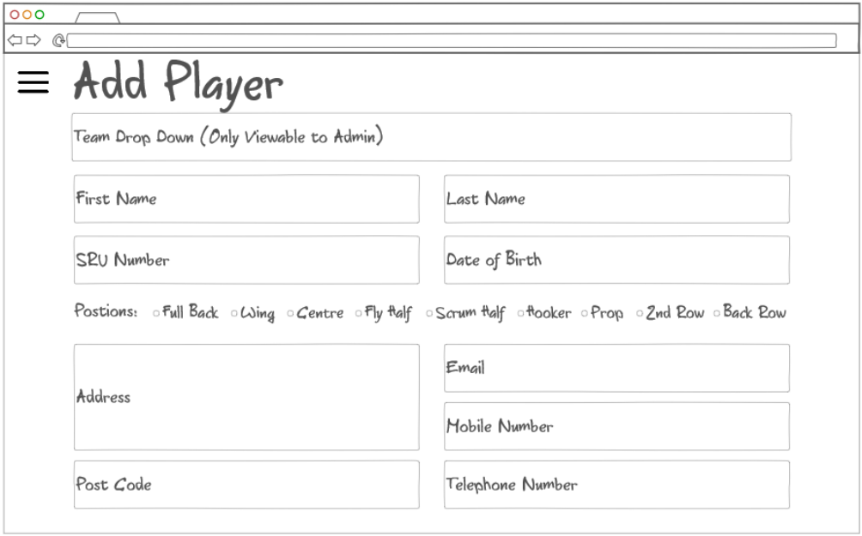

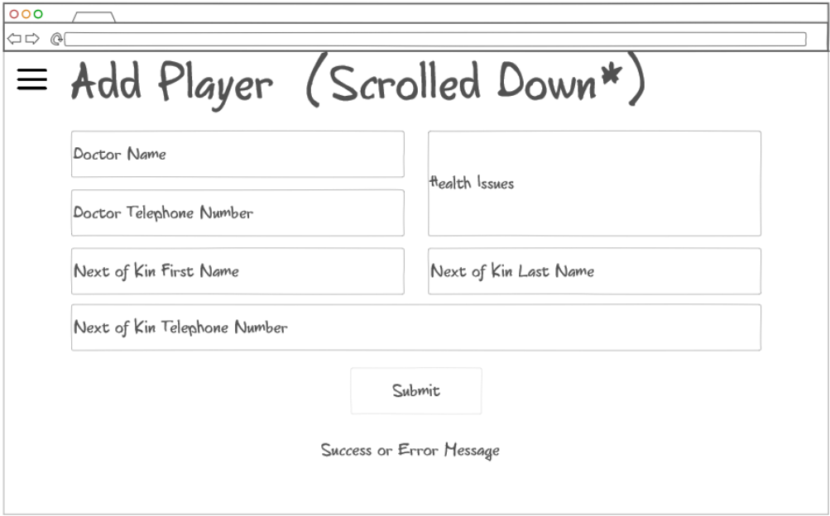

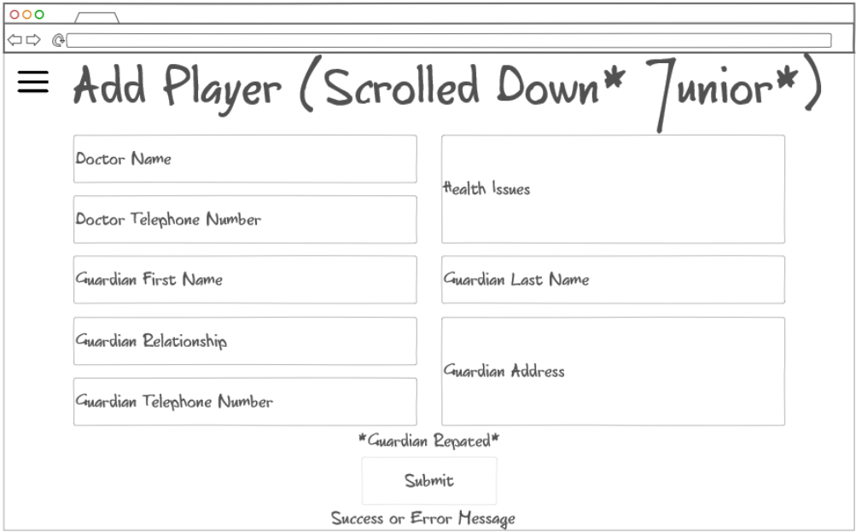

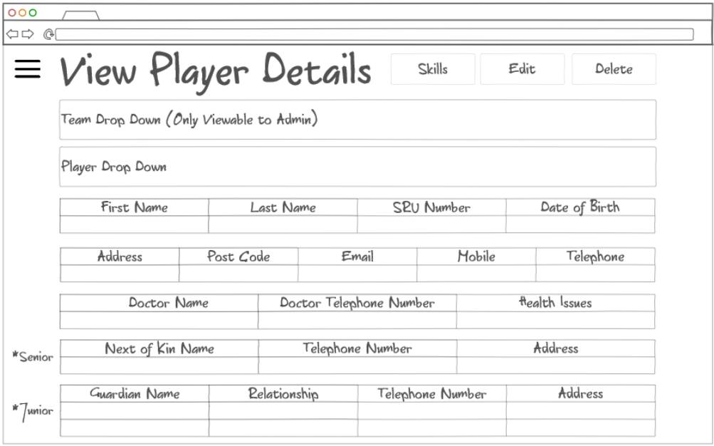

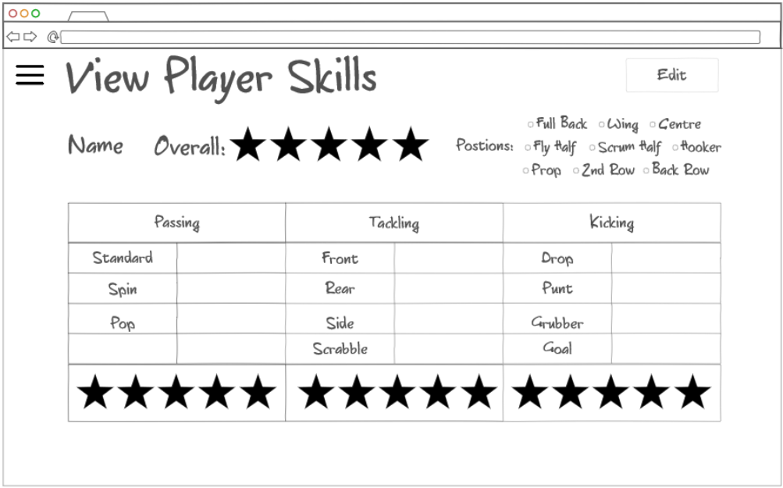

##### Match

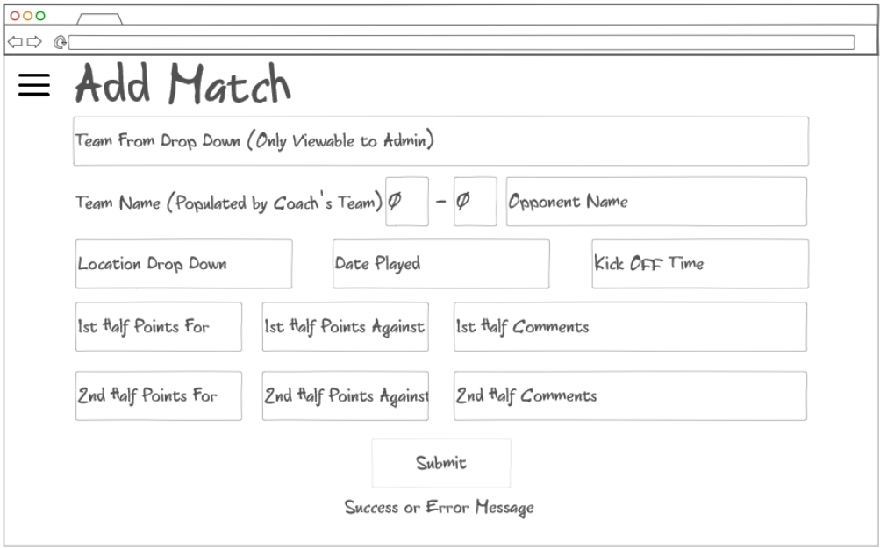

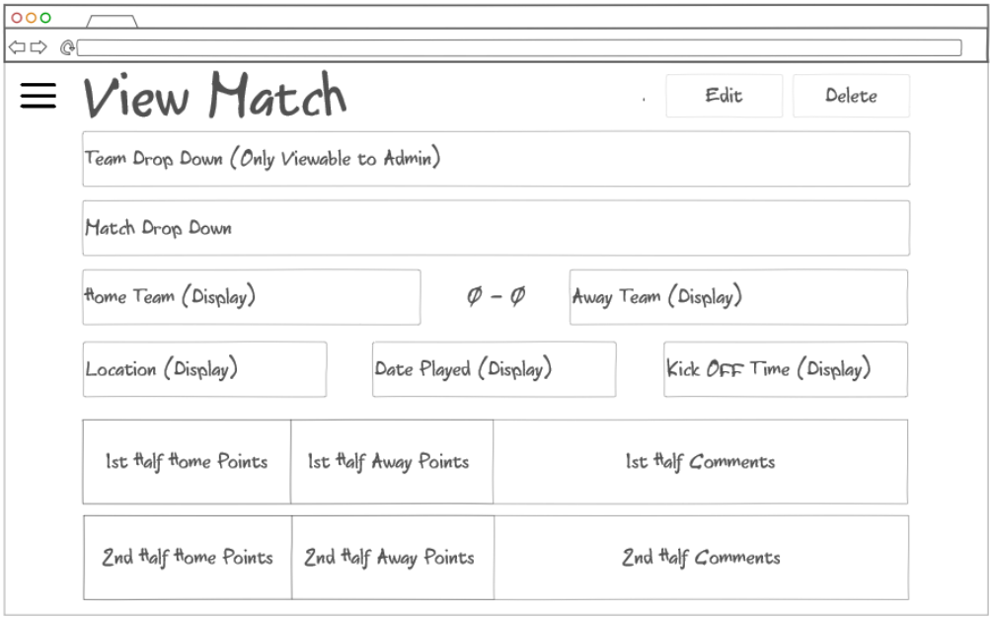

##### Training Session

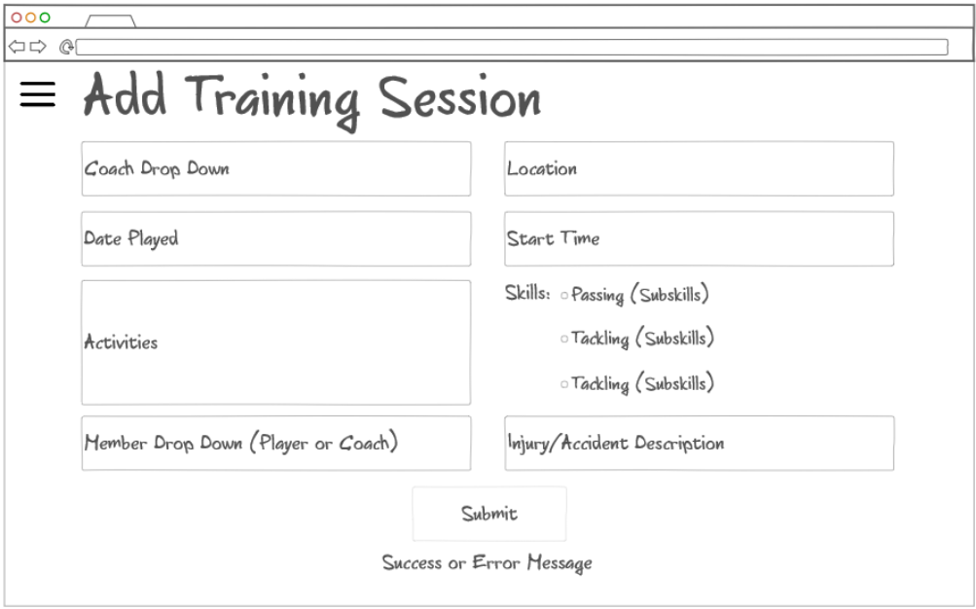

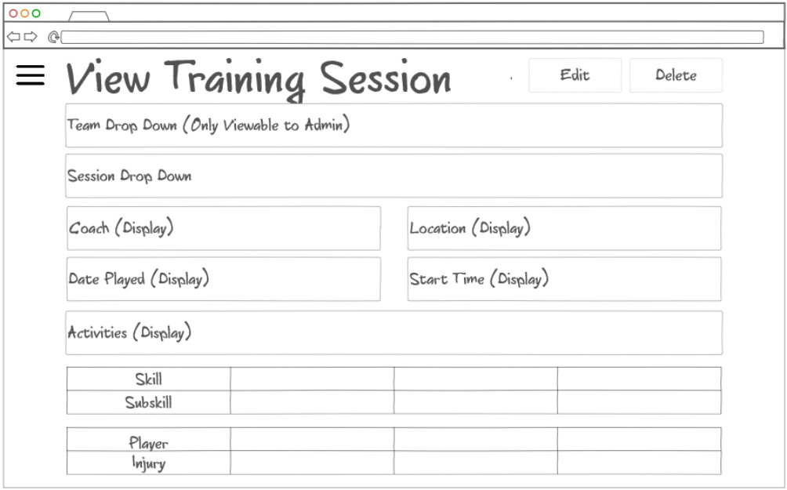

### Data Binding

These data binding diagrams show a high-level look at how the views (pages) interact with the models (classes). For simplicity, helper classes, such as doctors, guardians, or halves, are not shown here. It also doesn’t show the database usage; it implies that any creation is pushed to the database, and any viewing is pulled from it. The views are depicted in oval shapes, while the models are shown using rectangles. The arrows indicate the flow of data; the arrows illustrate the direction of data; some are one-way, while others are bi-directional. Much of this system will use a page to create something and another page to view.

#### Account

The login and create account pages interact with the account; creating the account pushes data one-way while logging in returns the user’s username for display on the view. Users will be logged in to either an admin or a coach account, depending on their access level.

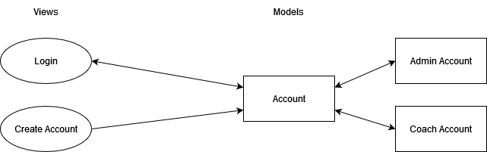

#### Secretary (Admin)

The following diagram assumes a user is logged in to an admin account; this depicts the creation and viewing of teams or coaches. The data flow is only one way to the model for creation or the view for viewing.

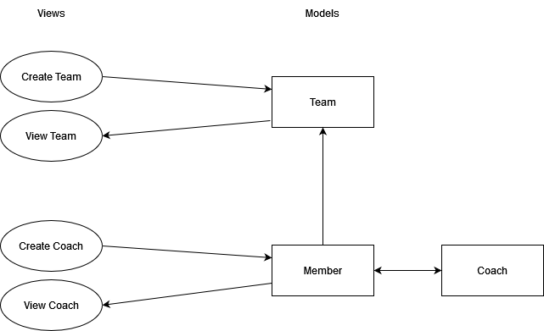

#### Coach

The following diagram assumes a user is logged in to a coach account; this depicts the creation and viewing of players, matches, or training sessions. The data flow is only one way to the model for creation or the view for viewing.

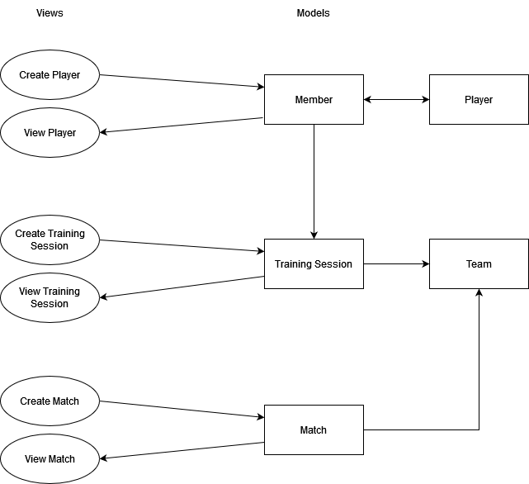

# References

GDPR.EU, 2024. *Complete guide to GDPR compliance.* [Online]   
Available at: https://gdpr.eu/  
[Accessed 16 02 2024].

GOV.UK, 2024. *Data protection.* [Online]   
Available at: https://www.gov.uk/data-protection  
[Accessed 16 02 2024].

IBM, 2021. *Password Policies.* [Online]   
Available at: https://www.ibm.com/docs/en/spim/2.0.0?topic=administration-password-policies  
[Accessed 16 02 2024].

Microsoft, 2024. *Windows 10 Home and Pro.* [Online]   
Available at: https://learn.microsoft.com/en-us/lifecycle/products/windows-10-home-and-pro  
[Accessed 18 02 2024].

Nielsen, J., 2024. *10 Usability Heuristics for User Interface Design.* [Online]   
Available at: https://www.nngroup.com/articles/ten-usability-heuristics/  
[Accessed 22 02 2024].

Pitchero, 2024. *Award winning technology for sports clubs.* [Online]   
Available at: https://www.pitchero.com/  
[Accessed 19 02 2024].

Scottish Rugby, 2022. *AGE GRADE LAW VARIATIONS.* [Online]   
Available at: https://scottishrugby.org/wp-content/uploads/2022/10/Mini-Boys-AGLV-Overview.pdf  
[Accessed 19 02 2024].

Scottish Rugby, 2024. *INSURANCE.* [Online]   
Available at: https://scottishrugby.org/rules-and-regulations/player-welfare/insurance/  
[Accessed 19 02 2024].

Scottish Rugby, 2024. *Scottish Rugby.* [Online]   
Available at: https://scottishrugby.org/  
[Accessed 12 02 2024].

Scottish Rugby, 2024. *SCRUMS.* [Online]   
Available at: https://scottishrugby.org/scrums/  
[Accessed 12 02 2024].

Stych, 2022. *What is password hashing?.* [Online]   
Available at: https://stytch.com/blog/what-is-password-hashing/  
[Accessed 16 02 2024].

World Rugby, 2024. *Scoring points.* [Online]   
Available at: https://www.world.rugby/the-game/beginners-guide/points  
[Accessed 19 02 2024].